Year 6 – Summer 1: Electricity and Engineering
Key Theme

Key Figure
Sir James Dyson (b.1947)
British Engineer: Dual Cyclone Bagless Vaccum Cleaner
Second richest person in the UK with an estimated net worth of £23 billion.

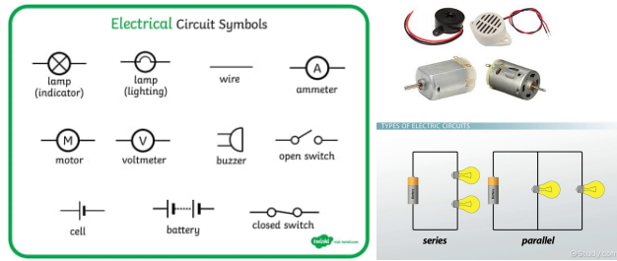
Sticky Knowledge & Skills
- We use scientific symbols to represent the components (parts) of a circuit.
- Circuit diagrams must be based on a rectangle and drawn with a ruler.
- The brightness of a bulb or the loudness of a buzzer is affected by the number of cells in a circuit.
- The brightness of a bulb or the loudness of a buzzer is affected by the voltage of cells in a circuit.
- The number of components in a circuit can affect how they function.
- The arrangement of components in a circuit can affect how they function.
- The length of wires in a circuit can affect how the components function.

Key Vocabulary
circuit | a closed loop for electricity to travel around
cell (battery) | a stored source of electricity
circuit symbols | an internationally agreed code for recording electrical circuits (see diagram)
component | a part used in an electrical circuit
conductor | an object that allows electricity to flow through it  easily (objects made of metal are good conductors)
electricity | a form of energy caused by electrons moving
insulator | an object that does not allow electricity to flow through it easily
motor | a machine that turns electrical energy into  movement
switch | a switch turns an electrical circuit on or off by completing or breaking the circuit
voltage | a force that makes electricity flow through a wire (it is measured in volts)

Key Text

Links to past learning
In year 4 we learnt about electricity. This was during the COVID isolation period so our practical work was limited.

Core Value Focus
Curiosity
Critical Thinking
Resilience

Science (Y4 consolidation) |  | Science (Y6 new learning)
Name 4 appliances that run on electricity:  Label this diagram:  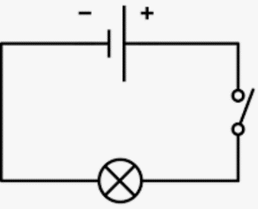  Name 3 common conductors:  Name 3 common insulators:  Will this circuit work? Why/why not?  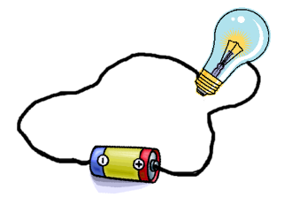 | TV, washing machine, wifi, tumble dryer, computer etc.  Wires, cell (battery), switch, bulb  Copper, aluminium, gold, silver  Glass, plastic, wood, rubber  No – the wire is connected to the insulator (glass) not the conductor (metal) | 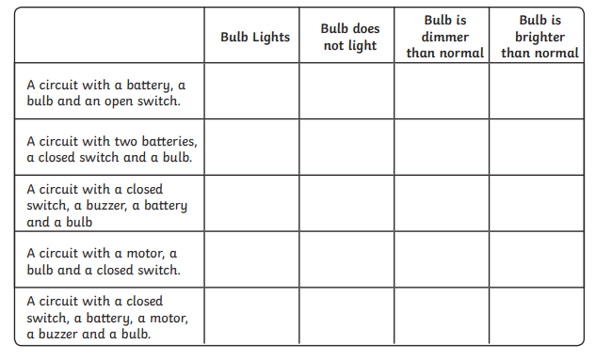  Draw a circuit diagram in which the switch can be used to turn the motor on and off.  You MUST use these three symbols in your diagram.  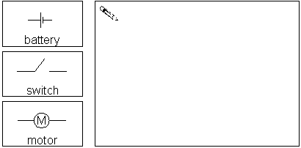 | 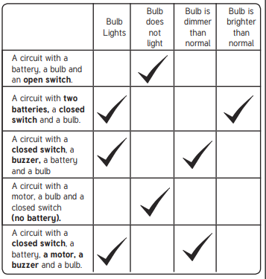  Check the following:  Circuit drawn with a ruler in rectangular shape  No gaps in wires  Correct symbols are used

