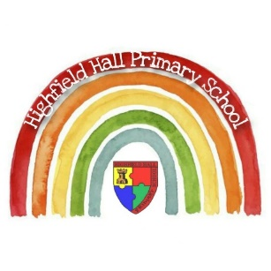

|  |
| --- |
| **Key Theme** |
|  |

Year 3 – Autumn 2: One Little Drop

|  |
| --- |
| **Key Texts** |
|  |

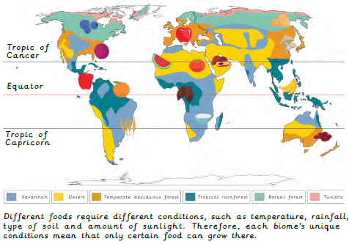

|  |
| --- |
| **Sticky Knowledge & Skills** |
| * I know what food miles are and why they are important. * I understand the advantages of importing food. * I understand the disadvantages of importing food. * I know what seasonal food is and why this is more sustainable. * I know what fossils are and can name 2 types of fossil. * I understand how fossils are formed. * I know what a puja tray is and what items I would find on one. * I understand what karma means to Hindus. |

|  |
| --- |
| **Core Value Focus** |
| Critical thinking, curiosity, compassion, creativity |

|  |  |
| --- | --- |
| **Key Vocabulary** | |
| Food miles | The distance food has travelled to reach you. |
| Import | An item brought in from a different country. |
| Consume | To buy, use or eat. |
| Trade | The buying and selling of goods or services. |
| Cooperative | A group of people working together who share ideas and income. |
| Responsible trade | A process to ensure workers have a voice, can get the best deal for their product and work in safe conditions. |
| Seasonal food | Food which is best eaten in a particular season. |
| Sustainability | A way of doing something that does not harm the environment. |
| Source | A place where something can be originally found. |

|  |
| --- |
| **Links to past and future learning** |
| In Year 2 we learn about the world’s continents and oceans. We learn the difference between human and physical geography. Last term we learnt about compass points.  In Year 4 we learn more about the climate zones in different parts of the world, and biomes, how the Earth is tilted on its axis, and how this can affect the climate. |

|  |  |  |  |  |  |
| --- | --- | --- | --- | --- | --- |
| Geography | | Science | | RE | |
| What is one advantage of importing food?  What is one disadvantage of importing food?  What is seasonal food?  What are food miles?  What does sustainability mean? | Possible answers include: Helps support communities in developing countries.  Provides people with a wider variety of food.  Creates relationships with other countries.  Possible answers include:  May encourage deforestation to produce enough food.  Increases food miles.  Can sometimes be more expensive if they have been produced through a responsible trade organisation.  Food that is best eaten in a particular season.  The distance food has travelled to reach you.  A way of doing something that does not harm the environment. | What is a fossil?  Name 2 types of fossils.  Explain how fossils are formed. | Fossils are the remains or traces of animals or plants that were once alive.  Trace fossils / body fossils or mineralisation fossils  1- An animal dies and is covered with sediment.  2 – The soft parts rot away and the bones remain making a mould.  3 - Sediment enters the mould to make a cast fossil.  4- Over time the sediment hardens into rock and forms a fossil.  5 – Erosion and weathering cause the rock to become exposed. | What items would you find on a puja tray?  What are the items on the puja tray used for?  What does karma mean to a Hindu?  What does moksha mean to a Hindu?  What does Dharma mean to a Hindu? | Bell / Flowers / Diva lamp / Water / Spoon / Sweets or sugar / incense burner and sticks / Murtis – statues of Gods or images of Gods  Bell- to wake the deity up for worship  Flowers- represents the beauty and fragrance of the created world  Diva lamp- for aarti (Aarti- symbolises that worship removes darkness) Water in a pot-represents life  Spoon-used to give water to worshippers after it has been blessed  Murti-to worship  Sweets or sugar - an offering of food for the deity  They believe life is a cycle of birth, death and rebirth, with our actions in this life, our “**karma**”, affecting what happens in the next life  The end of the cycle of death and rebirth  A person's duty / religious or moral duty – duty as a father or mother |