# H:\Logo.jpgYear 1 – Autumn 1 Lost and Found

|  |
| --- |
| **Key Texts** |
|  |

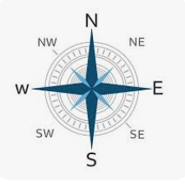

|  |  |
| --- | --- |
| **Key Vocabulary** | |
| **Recycle** | Convert (waste) into reusable material. |
| **North Pole** | Northern hemisphere where the Earth’s axis of rotation meets the surface. |
| **South Pole** | Southern hemisphere where the Earth’s axis of rotation meets the surface. |
| **Ocean** | A large body of water which covers a large area of the Earth. |
| **Reuse** | Use again or more than once. |
| **Compass** | An instrument containing a magnetized [pointer](https://www.google.com/search?sca_esv=a582e2bf57d0a7d9&sca_upv=1&biw=1536&bih=703&sxsrf=ADLYWIJk33Cg3Ga352JmUNF5hn7AzijSMw:1724929945427&q=pointer&si=ACC90nypsxZVz3WGK63NbnSPlfCBTZV6EglGULa7bbjC4kkU9Cw1_Rhx9JcPTMPMMjyP8ccsOZpbKcbTSyXQCbZ7O4RW2Vn0gA%3D%3D&expnd=1&sa=X&ved=2ahUKEwj-k6PliJqIAxVQQEEAHQNKD98QyecJegQIJxAP) which shows the direction of magnetic north and bearings from it. |

|  |
| --- |
| **Key Theme** |
| \\HIGHFIELDDC01\Redirection$\Staff\mike.bywaters\Downloads\Place in the world icon-modified.png |

|  |
| --- |
| **Core Value Focus** |
| Creativity, critical thinking, curiosity, resilience, emotional heath. |

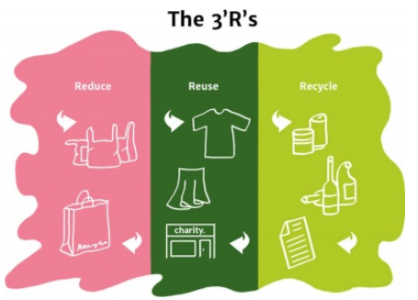

|  |
| --- |
| **Geography Sticky Knowledge** |
| * The town I live in is called **Chesterfield**. * Chesterfield is in **England**, which is a country. * **Human** (houses, shops, parks, roads) and **physical** features (river, woodlands) of **Chesterfield**. |

|  |
| --- |
| **Links to past and future learning** |
| * **Music:** Last year we explored instruments. * **RE:** We learnt about the world around us last year. * **English:** We started learning how to use phonics when writing last year. * **Maths:** We learnt to count to 10 last year, we will be building on this. |

|  |  |  |  |  |  |
| --- | --- | --- | --- | --- | --- |
| Geography | | Science | | RE | |
| What is the name of the town we live in?  What is the name of our country?  Which of these is a physical feature?  Which of these is a human feature?   |  | | --- | | What are the countries of the United Kingdom? | | What are the capital cities of the United Kingdom? | | What are the oceans and seas around the United Kingdom? | | **Chesterfield,** England, Europe  Chesterfield, **England,** Europe  road, house**,** **mountain**  river, **house,** mountain   |  | | --- | | England, Scotland, Wales  and Northern Ireland | | London, Edinburgh,  Cardiff and Belfast. | | Atlantic Ocean, North  Sea, Irish Sea and Channel | | |  | | --- | | Can you point to your head, neck, arms, elbows, legs, knees, face, ears, eyes, hair, mouth, teeth? | | What are the 5 most common senses? | | Can you identify whether these are fish, amphibians, reptiles, birds or mammals? | | Which of these are carnivores, herbivores and omnivores? | | How are cats, fish and birds the same and different? | | |  | | --- | |  | | Taste, touch, sight, hearing, smell | | Snake, mouse, penguin. | | Human, shark, sheep | | Bones, feathers, fur etc. | | What are the celebrations where Christians say “thank you” to God?  What happened in the creation story?  On which day do Christians believe God rested when he was creating the world? | Christmas, Easter, Harvest  *Can give examples…..*   * *Jesus healed someone who was sick.* * *God gave people food.* * *God made the world.*   God created heaven and earth, plants, animals, and people  The seventh day. |