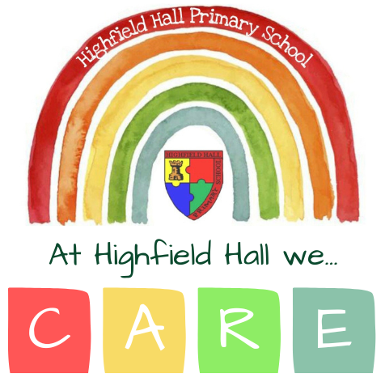

Highfield Hall Child-Friendly Anti-Bullying Policy

What is bullying?

In our school, we CARE; we are Compassionate, Aspirational Respectful, and Emotionally healthy, and we want you to be these things too.

Hopefully, most of the time that you are in school, everyone will show that they CARE.

However sometimes in school, **other children can hurt our bodies**. This can be an **accident** (for example if they trip over and land on you, or think they’re making a joke), or it can be **on purpose**.

Sometimes, children can **hurt our feelings** by using unkind words, or leaving us out of games.

If this happens once, this is not bullying, but you can still tell any grown-ups and they will help.

If it happens **more than once** then it could be bullying. If you tell the grown ups at school they will help. If you tell your grown ups at home, they should contact Dr Bywaters to let him know and he will help.

If any grown-ups think that you might be being bullied, Dr Bywaters or another grown-up in school will talk to your parents to let them know. Dr Bywaters or another grown-up will check in with you every day to make sure that things are OK and that there have not been any more problems.

If there are more problems, Dr Bywaters will speak with the other child and their parents, to help them understand how their behaviour is affecting you, and help them to make better choices.

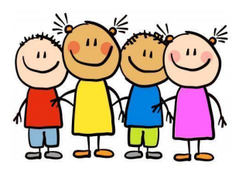

How can you help other children in school?

If you see someone else being unkind, you can help by:

* Asking if the person who is upset if they’re OK
* Telling a grown-up
* Offering to play with them