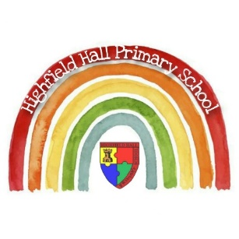
Key Theme


Year 4 – Spring 1 – Volcanoes & Earthquakes
Key Texts
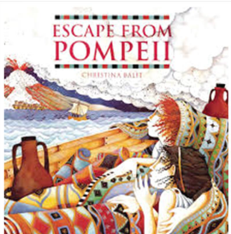

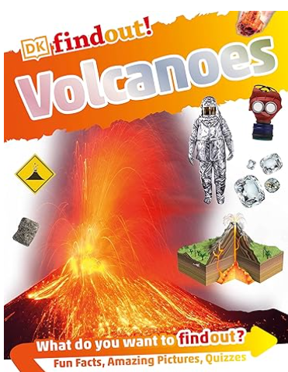

Sticky Knowledge & Skills
- Mount Vesuvius erupted in AD79.
- Pompeii was buried underneath a blanket of ash, pumice-stone and lava and was not re-discovered again until 1748.
- Approximately 2000 people in Pompeii lost their lives following the eruption.
- There are around 1,500 active volcanoes around the world.
- Tectonic plates move towards each other, away from each other and when this happens, it can cause both volcanic eruptions and earthquakes.
- The Ring of Fire is a region which spans much of the Pacific Ocean where a great many volcanic eruptions and earthquakes happen every year.

Labelled diagram of a volcano
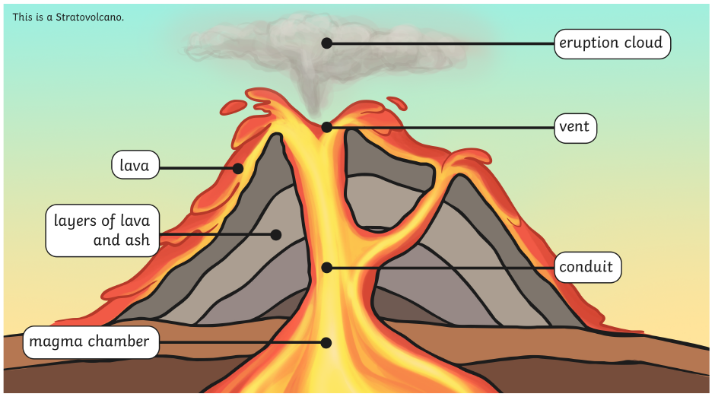

Key Vocabulary
active | An active volcano has erupted in the last 10,000 years.
dormant | A dormant volcano has not erupted in the last 10,000 years but could erupt in the future.
extinct | An extinct volcano will not erupt ever again.
volcanic eruption | A volcanic eruption is when lava and gas are released from a volcano.
core | The Earth’s core is the central layer which is made of iron and nickel.
mantle | The Earth’s mantle is the middle layer which is moving hot rock.
crust | The Earth’s crust is a thin outer layer of hard rock.
Ring of Fire | The Ring of Fire is a region in the Pacific Ocean which experiences lots of volcanic eruptions and earthquakes.
Mount Vesuvius | Mount Vesuvius is an active volcano situated in the Bay of Naples in Italy.
Richter scale | The Richter scale measures how powerful an earthquake is.
magnitude | How word used to describe how strong an earthquake is.
tremor | A small earthquake in which the Earth shakes slightly.

Geography |  | Science  (Changes of state) |  | RE  What do Hindus believe God is like?
What are the four layers of the Earth?  What is a tecnonic plate, and how are they involved in mountains being formed?  What causes an earthquake?  What are two types of volcano?  How are volcanoes formed? | Inner core, outer core, crust and mantle.  A section of the Earth's crust. When two plates push together they cause the plates to rise up, creating mountains.  Two tectonic plates moving against each other  Shield and composite  Magma, which is located at the centre of the Earth, pushes its way upwards through the Earth through a long shaft. When the magma travels through the Earth's crust, it emerges as lava. Once this lava has erupted onto the Earth's surface, it cools and hardens into a pile of rock. | What are the three main states of matter?  Name some properties of solids  Name some examples of solids (at room temperature)  Name some properties of liquids  Give some examples of liquids at room temperature  Name some properties of gases  What is air made from?  What can happen when materials are heated or cooled?  What are evaporation and condensation and how are they involved in the water cycle? | Solids, liquids and gases  They stay in one place, retain their shape if not affected by a force and can be held  E.g. wood, plastic, most metals, glass  They move around (flow) to fill the bottom of the container they are in, and are difficult to hold  Water, milk, juice  They expand to fill the space they are in and cannot be held  A mixture of gases  They change state from solid to liquid to gas (heated), or from gas to liquid to solid (cooled)  Evaporation - a liquid turning into a gas; condensation - a gas turning into a liquid. This happens in the water cycle (seas and rivers evaporate and become clouds, then condense as rain) | What does the Aum sound and symbol describe?  What is Brahman?  What does Namaste mean?  What is Atman?  Who is Shiva?  Who is Vishnu?  Who is Lakshmi? | Brahman, the first sound of creation  Hindu's believe Brahman is the source of everything in the universe  I bow to you  The spark of Brahman in every living creature  The destroyer of things (so new things can begin)  The sustainer of all living things  The deity of wealth and prosperity

