# H:\2022-2023\New folder\These ones\Nature icon 1.pngH:\Logo.jpg

|  |
| --- |
| **Key Theme** |
|  |

Year 6 – Spring 1: Our Bodies

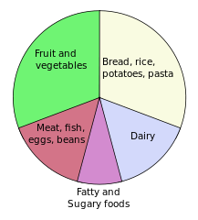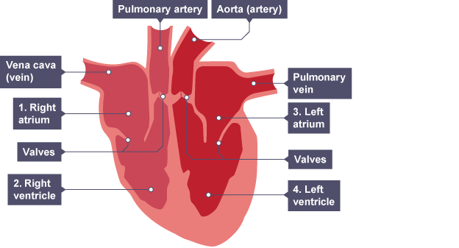

|  |
| --- |
| **Links to past and future learning** |
| Children will have studied the skeletal, muscular and digestive systems in lower key stage 2 |

|  |
| --- |
| Heart Health |
| Fatty food can clog arteries and veins, preventing blood from delivering what is needed. |
| Exercise can improve the health of a person by removing fatty deposits from the body. |
| Some exercises are designed to improve the fitness of the circulatory system by strengthening the organs and pulse rate. |

|  |
| --- |
| **Sticky Knowledge & Skills** |
| |  |  | | --- | --- | | 1 | Deoxygenated blood flows into the heart from the blood through the veins | | 2 | The blood is pumped out to the lungs through the pulmonary artery | | 3 | Blood is then oxygenated in the lungs | | 4 | Blood returns to the heart through the pulmonary vein | | 5 | The oxygenated blood is then pumped out of the heart through the aorta | | 6 | The blood travels around the body delivering oxygen and nutrients to the organs | |

|  |  |
| --- | --- |
| **Key Vocabulary** | |
| **arteries** | blood vessels that carry blood away from the heart |
| **blood** | a red fluid that is pumped by the heart and supplies the body with nutrients and oxygen |
| **blood vessels** | the narrow tubes through which blood is carried around the body |
| **capillaries** | microscopic blood vessels |
| **carbon dioxide** | a gas produced by animals and plants as they breathe out |
| **deoxygenated** | to be with reduced oxygen |
| **heart** | the organ in your chest that pumps blood around the body |
| **lungs** | two spongy organs inside your chest which fill with air when you breathe in. They remove carbon dioxide from blood and add oxygen. |
| **oxygen** | a colourless gas that exists in large quantities in the air. All animals need oxygen to live |
| **oxygenated** | to be with plentiful oxygen |
| veins | blood vessels that carry blood to the heart |

|  |
| --- |
| **Core Value Focus** |
| Critical thinking, emotional health, compassion. |

|  |  |  |  |
| --- | --- | --- | --- |
| Science | | RE | |
| What parts of of the body are involved in the circulatory system?  What does the heart do?  What are the three types of blood vessels?  What does blood do?  What do red blood cells carry?  What do white blood cells do? | The heart, blood vessels and blood.  Pumps blood around the body through blood vessels.  Arteries, veins and capillaries  Carries gases and nutrients around the body  Oxygen and carbon dioxide  Protects the body from infection | What does Dharma mean?  What is Samsara?  What is reincarnation?  What is karma?  What is ahimsa?  What is moksha? | Duty  The cycle of life, death and rebirth  The rebirth of Atman in another body  How a person's actions affect their future  The belief not to harm any living thing  The release from the cycle of life, death and rebirth |