# H:\2022-2023\New folder\These ones\Nature icon 1.pngH:\Logo.jpg

|  |
| --- |
| **Key Theme** |
|  |

Year 6 – Spring 1: Seeds of change

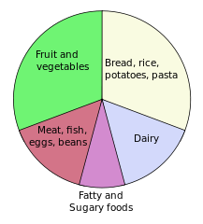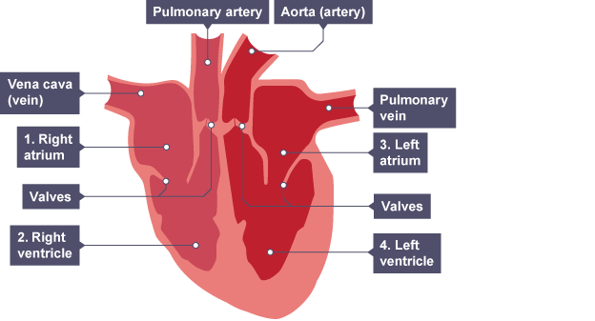

|  |
| --- |
| **Links to past and future learning** |
| Children will have studied the skeletal, muscular and digestive systems in lower key stage 2 |

|  |
| --- |
| **Key Texts** |
|  |

|  |
| --- |
| Heart Health |
| Fatty food can clog arteries and veins, preventing blood from delivering what is needed. |
| Exercise can improve the health of a person by removing fatty deposits from the body. |
| Some exercises are designed to improve the fitness of the circulatory system by strengthening the organs and pulse rate. |

|  |
| --- |
| **Sticky Knowledge & Skills** |
| |  |  | | --- | --- | | 1 | Deoxygenated blood flows into the heart from the blood through the veins | | 2 | The blood is pumped out to the lungs through the pulmonary artery | | 3 | Blood is then oxygenated in the lungs | | 4 | Blood returns to the heart through the pulmonary vein | | 5 | The oxygenated blood is then pumped out of the heart through the aorta | | 6 | The blood travels around the body delivering oxygen and nutrients to the organs | |

|  |  |
| --- | --- |
| **Key Vocabulary** | |
| **arteries** | blood vessels that carry blood away from the heart |
| **blood** | a red fluid that is pumped by the heart and supplies the body with nutrients and oxygen |
| **blood vessels** | the narrow tubes through which blood is carried around the body |
| **capillaries** | microscopic blood vessels |
| **carbon dioxide** | a gas produced by animals and plants as they breathe out |
| **deoxygenated** | to be with reduced oxygen |
| **heart** | the organ in your chest that pumps blood around the body |
| **lungs** | two spongy organs inside your chest which fill with air when you breathe in. They remove carbon dioxide from blood and add oxygen. |
| **oxygen** | a colourless gas that exists in large quantities in the air. All animals need oxygen to live |
| **oxygenated** | to be with plentiful oxygen |
| veins | blood vessels that carry blood to the heart |

|  |
| --- |
| **Core Value Focus** |
| Critical thinking, emotional health, compassion. |

|  |  |  |  |
| --- | --- | --- | --- |
| Science | | RE | |
| Name 2 organs involved in the circulatory system  What gas is needed when we inhale?  What gas do we exhale? | Heart, Lungs  Oxygen  Carbon dioxide | 1.What does sacred mean?  2.Name 3 sacred buildings.  3.Why are there no images of Allah in Muslim art and architecture?  4.There are 99 names for Allah – can you name any of them?  5. Can you name an Islamic artist? And describe one of their works of art. | 1.Something that is sacred is believed to be holy and to have a special connection with God.   * St Peter's Basilica – The Vatican City, Rome. (Catholic – Christian) * St Pauls Cathedral – London (Anglican – Christian) * The Taj Mahal – Agra, Uttar Pradesh, India (Islam) * Liverpool Metropolitan Cathedral (Paddy’s Wigwam) * London Central Mosque – Regents Park, London * Ranganathaswamy Temple, Srirangam – India   3.They believe images mislead us rather than enlighten/educate us.  4.The only one God, The All Mighty, The Creator, The Giver of Gifts, The Provider  The Perfect Judge, The All Knowing etc  5.Yasmin Kathreda or Ahmed Moustafa  Yasmin Kathreda – 99 names of Allah painted in gold on a mirror / Ahmed Moustafa - 99 names of Allah written in Arabic on small cubes |