

|  |
| --- |
| **Key Theme** |
|  |

Year 4 – Autumn 1 – Do you hear what I hear?

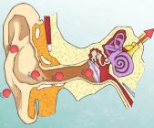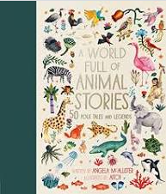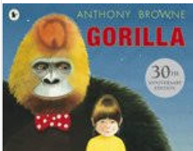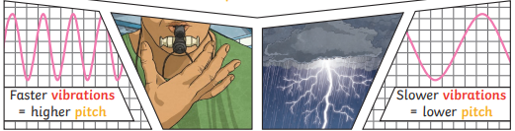

|  |  |
| --- | --- |
| **Key Vocabulary** | |
| Primate | A group of mammals that includes some of the most intelligent animals. The major kinds of primates are humans, apes, monkeys, tarsiers, lemurs, and lorises. There are more than 300 species, or types, of primates. |
| Ape | Apes are the. animals that are most closely related to humans. Both apes and humans are members of the scientific group of animals called primates. |
| Vibration | A quick movement back and forth. |
| Sound wave | **Vibrations** travelling from a sound source. |
| Volume | The loudness of sound. |
| Pitch | How low or high a sound is. |
| Ear | An organ used for hearing. |
| Particles | Solids, liquids and gases are made of particles. They are so small we are unable to see them. |
| Eardrum | A part of the ear which is a thin, tough layer of tissue that is stretched out like a drum skin. It separates the outer ear from the middle and inner ear. Sound waves make the eardrum vibrate |

|  |
| --- |
| **Key Texts** |
|  |

|  |
| --- |
| **Sticky Knowledge & Skills** |
| * We know that sound is created by vibrations. * We know that sound travels as a wave, vibrating particles. * We know that sound can travel through solids, liquids and gases. * We know that the vibrations hit our ear drum and then are passed through the parts of our ear. These then get turned into an electrical signal and is sent to the brain. |

|  |
| --- |
| **Core Value Focus** |
| Creative, Critical Thinking, Curious, Resilient, Emotionally Healthy |

|  |
| --- |
| **Links to past and future learning** |
| In music we have learned about pitch and dynamics. We have used instruments to make a range of different sounds in different ways. We have explored making long and short sounds with different instruments. |

|  |  |  |  |
| --- | --- | --- | --- |
| Science  (Sound) | | RE | |
| What is the definition of a sound wave?  When a sound gets quieter, what happens to the sound wave?  What is he measure of how high or low a sound is?  Soundwaves make the ________ vibrate.  What is the definition of soundproof? | A vibration traveling from a sound source.  It gets smaller.  Pitch.  Eardrum.  Something that prevents sound from passing through. | Who are the disciples?  What are the names of the four gospels?  What is Galilee?  What is a Parable? | A name for those who follow Jesus and believe that he is the Son of God.  The gospels of Matthew, Mark, Luke and John.  A lake in Judea around which Jesus did much of his teaching  A story with a meaning |