# H:\2022-2023\New folder\These ones\Nature icon 1.pngH:\Logo.jpg

|  |
| --- |
| **Key Theme** |
|  |

Year 4 – Autumn 2 - Rainforests (& South America).

|  |
| --- |
| **Sticky Knowledge & Skills** |
| * The largest rainforest in the world is the Amazon which is located in South America. * All rainforests can be found close to the equator in tropical climate zones where the weather is warm and wet all year round. * Rainforests are under threat around the world. Deforestation is one of the biggest problems as it is destroying the habitats of many plants and animals. |

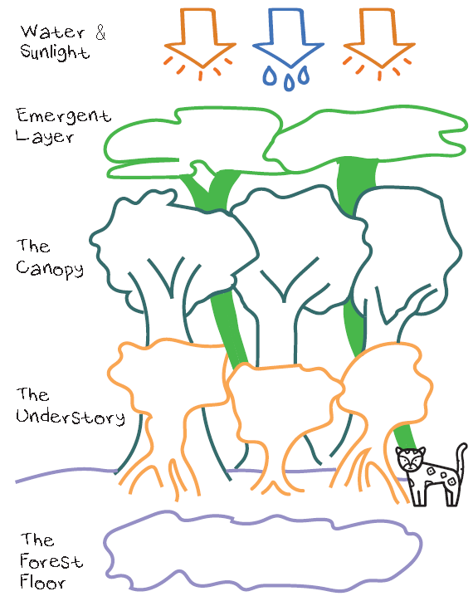

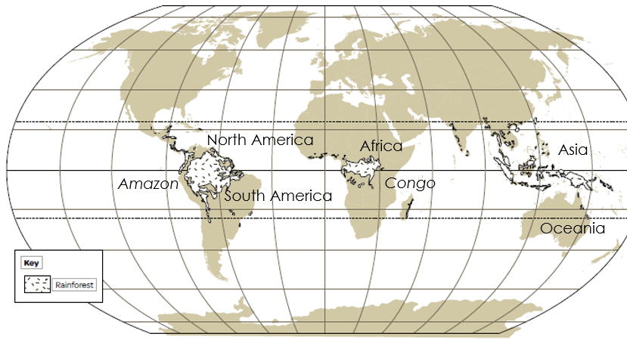

|  |
| --- |
| **Key Texts** |
|  |

|  |
| --- |
| **Links to past and future learning** |
| -Last half-term, you learnt about different climate zones. |

|  |  |
| --- | --- |
| **Key Vocabulary** | |
| rainforest | Forests that are home to many animals and plants. They are located close to the equator in tropical climate zones where it is warm and wet. |
| The Amazon | The Amazon is located in South America and it is the largest rainforest in the world. |
| equator | The equator is the invisible line which splits our planet equally into the Northern and Southern hemispheres. |
| rainforest layers | There are four important layers within a rainforest ----------------------------->>>>> |
| deforestation | The cutting down of trees on a large scale. |
| Manaus | A city in the middle of the Amazon rainforest in South America. |
| biodiversity | The number of different plants and animals found in a particular environment. |
| biome | A community of plants and animals that are suited to a particular climate. |

|  |
| --- |
| **Core Value Focus** |
| Critical thinking, emotional health, compassion. |

|  |  |  |  |  |  |
| --- | --- | --- | --- | --- | --- |
| Geography | | Science  (Electricity) | | RE What can we learn about religions about what is right and wrong? | |
| Where is the Amazon Rainforest?  Name the four layers of a rainforest.  What is deforestation?  What is biodiversity?  In which climate zone are rainforests found? | Brazil, South America.  The forest floor, the understory, the canopy and the emergent layer.  The cutting down of a large number of trees.  The number of different plants and animals found in a particular environment.  Rainforests are found in tropical climate zones. | Name 4 appliances that run on electricity:  Label this diagram:    Name 3 common conductors:  Name 3 common insulators:  Will this circuit work? Why/why not? | TV, washing machine, Wi-Fi, tumble dryer, computer etc.  Wires, cell (battery), switch, bulb  Various metals: copper, aluminium, gold, silver  Glass, plastic, wood, rubber  No – the wire is connected to the insulator (glass) not the conductor (metal) | What is a golden rule?  What are the ten commandments?  What rule could you create to make the world a ‘good’ world?  Name two things that a humanist believes in.  Name a Christian story about temptation?  How was Desmond Tutu guided by his religion? | A rule that is very important.  A set of rules that are followed in Judaism and Christianity.  *Various answers.*  There is no God, Science is the best method for understanding the world, we only have ‘one life’ so we need to make the most out of it, have empathy for others and the world we live in.  Adam and Eve/ The temptation of Jesus.  Desmond Tutu opposed apartheid and used his position as a Christian minister to fight it. He encouraged forgiveness and reconciliation. |