# H:\Logo.jpg

|  |
| --- |
| **Key Theme** |
|  |

**Year 4 – Summer 2 –** **Blue John**

Iron Age hill-forts, mountains & hills (UK).

|  |
| --- |
| **Sticky Knowledge & Skills** |
| * **That Iron Age people lived in farming communities.** * **The people lived off the land.** * **The Iron Age started around 800 BC.** * **Where the Iron Age fall on a timeline and the eras that fall both before and after.** * **Iron replaced bronze as the metal of choice because it was easier to find, tougher and easier to work with.** * **People lived in tribes and were often at war with one another.** * **Due to these wars, people protected themselves by building hillforts which were a group of round houses and farming land protected by stone wall** * **Sometimes, people of the Iron Age are referred to as `Celts`.** |

|  |  |
| --- | --- |
| **Key Vocabulary** | |
| Archaeologists | People who work out our history by looking at artefacts  that have been found. |
| Artefact | An object made by human beings |
| Barrow | long mound where bodies were buried |
| B.C. | Before Christ. A date like 250BC means 250 years before Christ was  born |
| Forge | where heating melts and allows metal to be made |
| Henge | upright stones ditches and mounds |
| Prehistoric | before the Romans and written records |
| Tribe/Tribal | group of people, often of related families, who live in the  same area and share the same language, culture, and history |

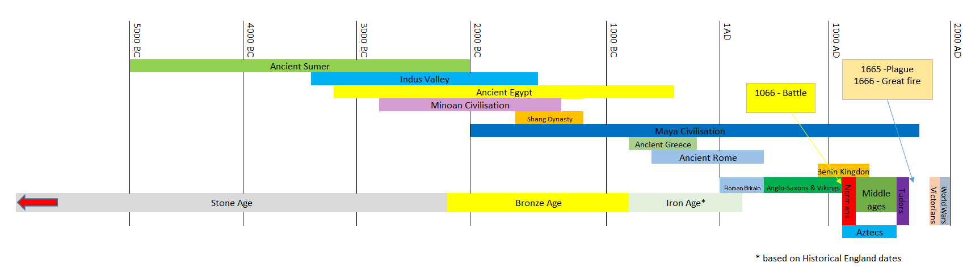

|  |
| --- |
| **Links to past and future learning** |
| In year 3 we learnt about the stone age -  In year 4 we will learn about the Iron Age and how this followed on from the Stone Age and the Bronze age. We will be learning about how the people of the Iron Age lived and their types of houses. We will be discovering their religion and their day to day lives. |

|  |
| --- |
| **Core Value Focus** |
| Curiosity, critical thinking, resilience, compassion. |

|  |
| --- |
| **Key Texts** |
|  |

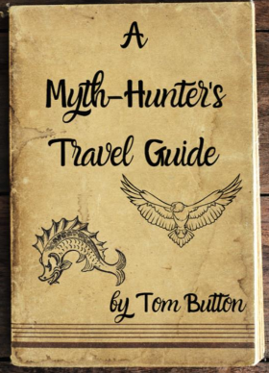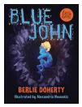

|  |  |  |  |  |  |
| --- | --- | --- | --- | --- | --- |
| History  (Iron Age) | | Science  (Living things and their habitats) | | RE | |
| What animals were hunted for food?  What are hill forts?  What was the typical type of buildings that they live in?  What is wattle and daub?  Did they believe in one god?  Who were the Druids? | Deer, wild boar and fish.  A defended settlement built on hilltops.  Round houses.  A mixture of animal dung, clay and straw.  They believed in over 400 different gods.  Druids were priests and religious leaders who carried out religious rituals. | What is a vertebrate?  What is an invertebrate?  What is a habitat?  What is an endangered species?  What does the word extinct mean? | An animal with a back bone.  An animal without a backbone.  An area or place in which a particular animal or plants may live.  A plant or animal where there are not many of their species left and scientists are concerned that the species may become extinct.  When a species has no more members alive on the planet, it is extinct. | 1. What is a milestone? 2. Name a milestone that has happened in your life so far. 3. Why is a baptism a significant milestone for a Christian? 4. Name an important Jewish ceremony which marks the move from childhood towards adulthood. 5. Name a Hindu ceremony that marks in their journey of life? | A significant event in life.  Various answers.  Baptism is a ceremony that symbolises a commitment to living a life as a Christian.  Bar and Bat Mitzvah  Namkarna—(Naming ceremony) Jatakarma—(welcoming the baby in to the family) Karnavedha—(Ear piercing ceremony) Mundane—(First haircut) Upananyana—(Sacred Thread ceremony) |