Key Vocabulary
Root | A plant's roots sit below the soil and the stem grows above it. The roots of a plant take up water and nutrients from the soil. They also anchor the plant to the ground and keep it steady.
Stem | - The stem carries water and nutrients to different parts of the plant. It also provides support and keeps the plant standing upright.
Leaf | - a flat structure of a plant, typically green and blade-like, that is attached to a stem directly or via a stalk.
Flower | - Some plants have flowers. These are involved in reproduction and produce seeds from which new plants grow
Life cycle | A life cycle is a series of stages a living thing goes through during its life.
Nutrient | Substance found in soil that helps plants grow and survive
Evaporation | The process in which warm water turns from a liquid to a gas in the air (water vapour).
Condensation | The process in which water vapour rises in the air, cools down and turns into small water droplets.
Precipitation | The process in which water falls from clouds to the ground, in the form of rain, sleet, snow or hail.
Delta | A wide area near where a river meets the sea which features a build-up of sand and sediment.
Estuary | The area where fresh water from a river meets salt water from the sea.
Floodplain | Areas of flat land on either side of a river that can become flooded if the river gets too full.
Meander | A bend or curve in a river.
Source | The place where a river starts.
An exploration of a multitude of journeys including;

- Science = plant growth journeys.
- English = journey through poetry and story writing.
- Maths = a journey into fractions
- Topic = journey through school using map and compass skills and exploring a journey of new skills; sewing.
Sticky Knowledge & Skills
- I know a root, stem/trunk, leaves and flowers
- I know the requirements of plants for life and growth (air, light, water, nutrients from soil, and room to grow) and how they vary from plant to plant
- I know the way in which water is transported within plants
- I know the part that flowers play in the life cycle of flowering plants, including pollination, seed formation and seed dispersal.

- I know the process of a Design and Technology project – research, design, make, evaluate

- I can communicate effectively and share opinions
- I can identify a position on a map
- I can use different strategies to overcome challenges
- I can talk about my own strengths
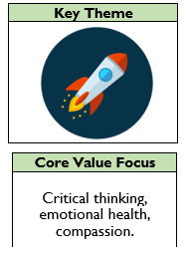

Links to past and future learning
- In Y2 we learnt about sequencing a set of events in chronological order and give reasons for their order.
- In Y3 we learnt about the Stone Age
- In Y4 we will learn about other early civilisations
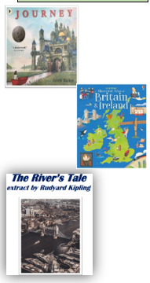

D&T |  | Geography |  | Science |  | RE
What is a prototype?  What is a template?  How many different materials do you know? | a model that is made to test whether a design will work  a shape drawn to exact shape and size and used to assist cutting  Felt, cardboard, paper, wood, brick, foil, tissue, etc | What are the 8 points of the compass?  What is the ‘thumbing technique?’  Draw the start and finish symbols on a map  Name some of these map symbols  What is a bird’s eye view? | north, north-east, east, south-east, south, south-west, west and north-west.  Top navigators use a technique known as "thumbing the map". This is holding the map so that yo2ur thumb is next to your current position. Then when you next look you can instantly focus in on the right place.  The view from above | What is a root of a plant and where do you find it?  What is a leaf of a plant and where do you find it?  What is a flower?  What is a nutrient for a  plant and where do you find it?  Describe the life cycle of plant  What is a stem?  Draw and label a plant.  What is a root of a plant and where do you find it? | A plant's roots sit below the soil and the stem grows above it. The roots of a plant take up water and nutrients from the soil. They also anchor the plant to the ground and keep it steady.  A flat structure of a plant, typically green and blade-like, that is attached to a stem directly or via a stalk.  Some plants have flowers. These are involved in reproduction and produce seeds from which new plants grow  Substance found in soil that helps plants grow and survive  - Seed  - Germination and Seedling  - Growing to Maturity  - Flowering, Pollinating, and Seeding  - Seed Dispersion  The stem carries water and nutrients to different parts of the plant. It also provides support and keeps the plant standing upright.  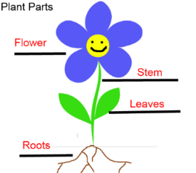  A plant's roots sit below the soil and the stem grows above it. The roots of a plant take up water and nutrients from the soil. They also anchor the plant to the ground and keep it steady. | Who is God?  What does the Holy Trinity mean?  What is praying? Why do Christians like to pray?  Who was Moses?  What do Muslims call God?  What are Murtis?  Tell me about Brahman - Brahma, Vishnu or Shiva | Christians believe God is Father, God is Light, God is Creator, God is Love  God is the Father, the Son and the Holy Spirit  Praying is a way of talking to God. Christians pray to God for guidance, to say thankyou, to ask for help. They believe God talks back to them  Moses was the prophet who led the Jewish slaves out of Egypt.  The Arabic word for God is Allah.  Murtis are special statues who Hindus pray to.  Brahman is the Trimurti and made up of three gods. Brahma is the creator and is part of the Trimurti. Vishnu is the preserver and part of the Trimurti, Shiva is the destroyer and part of the Trimurti

