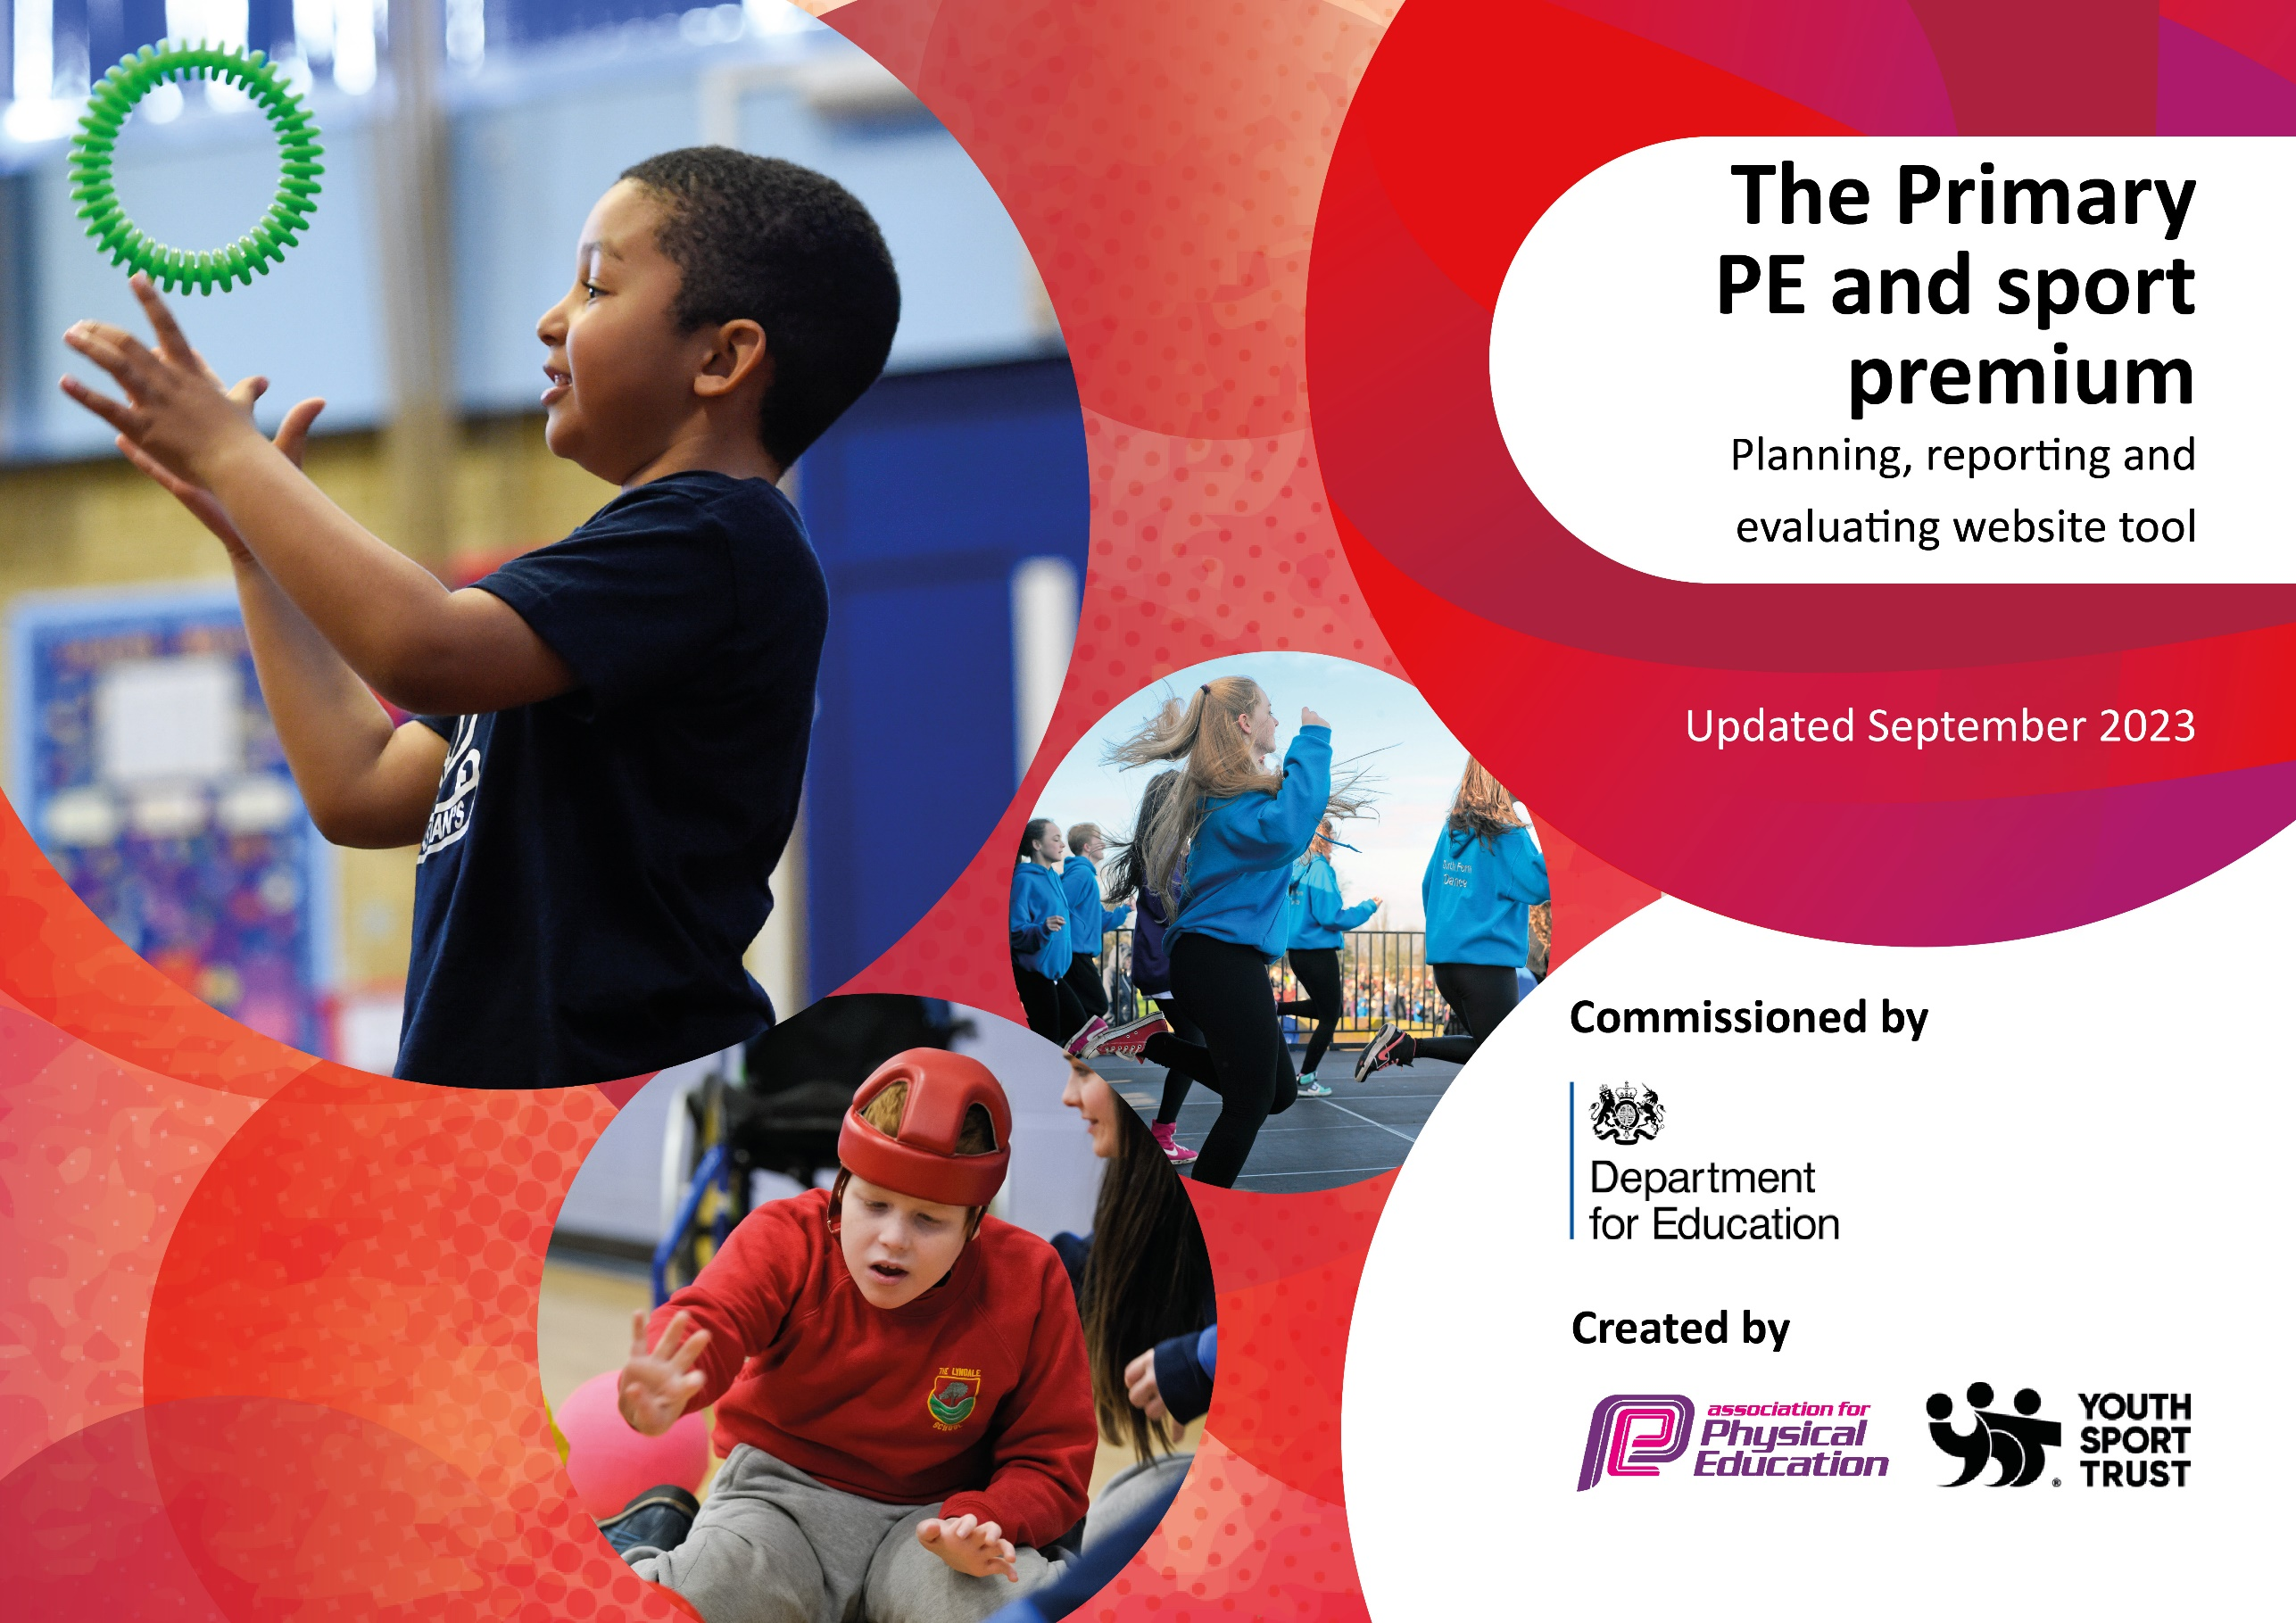

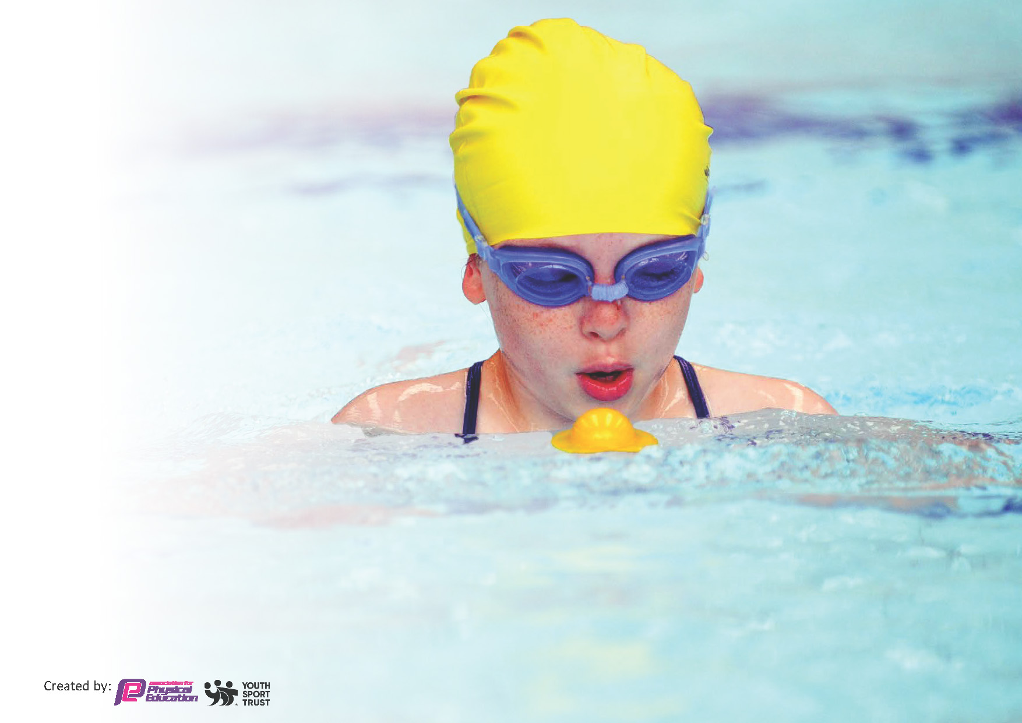
This template can be used for multiple purposes:
by:
- It enables schools to effectively plan their use of the Primary PE and sport premium
- It helps schools to meet the requirements (as set out in guidance) to publish information on their Primary PE and sport premium
- It will be an effective document to support Ofsted inspections enabling schools to evidence progress in Physical Education (PE) and evidence swimming attainment, which forms part of the PE National Curriculum. We would recommend schools consider
the Intent, Implementation and Impact of any spend, as examined within the Education Inspection Framework.

It is important that your grant is used effectively and based on school need.

Schools must use the funding to make additional and sustainable
improvements to the quality of the PE, School Sport and Physical Activity (PESSPA)
they offer. This means that you should use the Primary PE and sport premium to:

- Build capacity and capability within the school to ensure that improvements made now will benefit pupils joining the school in future years
- Develop or add to the PESSPA activities that your school already offers.

The Primary PE and sport premium should not be used to fund capital spend projects; the school’s core budget should fund these. Further detail on capital expenditure can be found in the updated Primary PE and sport premium guidance.

The Primary PE and sport premium guidance, outlines 5 key priorities that funding should be used towards. It is not
necessary that spending has to meet all the key priorities, you should select the priorities that you aim to use any funding towards.

Although completing this template is not a requirement for schools, schools are required to publish details of how they spend this funding. Schools must also outline what the impact this funding has had on pupils’ PE and sport participation and attainment and how any spending will be sustainable in the future. All funding must be spent by 31st July 2024.

The Department for Education has worked closely with the Association for Physical Education (afPE) and the Youth Sport Trust (YST) to develop this template and encourages schools to use it. This template is an effective way of meeting the reporting requirements of the Primary PE and sport premium.
Review of last year’s spend and key achievements (2022/2023)

We recommend you start by reflecting on the impact of current provision and reviewing your previous spend.

Activity/Action | Impact | Comments
Swimming lessons from Y2 – Y6  Affiliation with SHAPE partnership  Enrichment – after school clubs  Biathlon – sponsored event | At the end of Y6:  93% of children could swim confidently and proficiently of at least 25m.  89% of children could use a range of strokes effectively.  100% of children could perform safe self-rescue in different water based situations.  All children from Y1 – Y6 experienced three physical activity sessions led by SHAPE.  23 sporting events and festivals were accessed throughout the year, aimed at different Year groups and different abilities (INSPIRE, CONNECT and ACHIEVE)  Mini-leaders – 20 children selected to take part in training to deliver games and activities at lunchtime.  A variety of after school clubs were offered last year:  Dance with Thea – street dance, dance show preparation  SAMBA – multi-skills, ball games, athletics  CFC – mixed football and girls’ only sessions  All children from Nursery to Y6 took part in this event.  N – Y1 cycled and ran  Y2 – Y6 swam and ran  The whole school coming together for an event was a joyous experience that everyone could take part in | Feedback from staff have requested that swimming to move from the groups swimming every other week to block swimming – a group swims for a half term and then this swaps for the second half term.  This raises the profile of physical activity across school. However, moving forward this has to be increased with more participation in physical activity from 4-7yr olds. Parental engagement is critical for this to work.  Having differentiated sporting events allows ALL children to feel included. Children can feel safe attending an event therefore maximum participation and enjoyment can be gained from these opportunities.  Due to staffing issues at lunchtime – mini-leaders was not fully utilized. This needs revisiting 23/24 to make it more effective. Lunchtimes in general needs to be a primary focus next year to maximize opportunity for quality physical activity.  Some of these clubs were subsidized so they could run. A few were low attended. Despite, listening to pupil voice. After school club offer needs reviewing on how to boost numbers. What are holding parents back? Time, cost, not the right club  To run a whole school sporting event to raise money for school but for 23/24 needs to be different – this will keep the pupils engaged.  BUDGET SPENT £8666.73  BUDGET CARRY £10,708.07  PLUS 23/24 SPORT BUDGET £18,000

Key priorities and Planning
This planning template will allow schools to accurately plan their spending.

Action – what are you planning to do | Who does this action impact? | Key indicator to meet | Impacts and how sustainability will be achieved? | Cost linked to the action
OPAL – outdoor play and learning.  Raising the profile of physical activity from EYFS and KS1  Affiliation with SHAPE partnership  REAL PE | The whole school  Children aged 4yrs – 7yrs.  Parents  This will be Sophie Ross and Charlie Riley’s supported experiment  This affiliation impacts the whole school – staff/ children/ lunchtime  Teachers delivering the primary curriculum.  The children receiving a FUN, comprehensive and progressive PE experience | Key indicator 2 -The engagement of all pupils in regular physical activity – the Chief Medical Officer guidelines recommend that all children and young people aged 5 to 18 engage in at least 60 minutes of physical activity per day, of which 30 minutes should be in school.  Key indicator 4: offer a broader and more equal experience of a range of sports and physical activities to all pupils  Key indicator 2: increasing engagement of all pupils in regular physical activity and sport  Key indicator 3: raising the profile of PE and sport across the school, to support whole school improvement  Key indicator 4: offer a broader and more equal experience of a range of sports and physical activities to all pupils  Key indicator 1: Increasing all staff’s confidence, knowledge and skills in teaching PE and sport  Key indicator 2: increasing engagement of all pupils in regular physical activity and sport  Key indicator 3: raising the profile of PE and sport across the school, to support whole school improvement  Key indicator 4: offer a broader and more equal experience of a range of sports and physical activities to all pupils  Key indicator 5: Increase participation in competitive sport  Key indicator 1: Increasing all staff’s confidence, knowledge and skills in teaching PE and sport  Key indicator 3: raising the profile of PE and sport across the school, to support whole school improvement | More pupils meeting their daily physical activity goal  Research shows that children's mental and physical health is getting worse and that great play can make it better.  It will ensure that every child has at least one hour's outstanding outdoor play every school day.  Raising the profile of PE at school and at home  - Increase active learning  - Celebrate and reward  - Track pupil activity  - Improve engagement  CPD – staff and lunchtime staff can access training throughout the year  Three times a year, Y1 – Y6 access three bespoke physical activity sessions  Across the school all Year groups attend festivals and events – these are differentiated for sporting ability – INSPIRE, CONNECT and ACHIEVE.  This scheme enables staff to confidently deliver the PE curriculum. As a school we have access to CPD through REAL PE (refresher courses and training for new staff)  The children receive a PE programme that is progressive and develops children’s Agility, Balance and Coordination – this are all the fundamental skills needed to be able to play any sport. | £10,000 costs to support the implementation of improvement project  BURSTs physical activity APP  £295 plus 10% off price being affiliated to SHAPE partnership  This was paid up front two years a go for affiliation for three years (this is 3 out of 3)  Event/ festival costs (estimates):  Coach cost: £1600  Supply cost: £1610  £700 subscription for the year

Key achievements 2023-2024
This template will be completed at the end of the academic year and will showcase the key achievements schools have made with their Primary PE and sport premium spending.

Activity/Action | Impact | Comments
AUTUMN TERM:  IN SCHOOL:  Year 5&6 Mini-leader training delivered by SHAPE  Whole school physical activity session  Bikeability level 2 delivered by Wheelyfunwheels  Derbyshire cricket coaching  Derbyshire cricket coaching SEND  FESTIVALS AND EVENTS:  Year 5&6 The Cube delivered by SHAPE  KS2 SEND Panathlon delivered by SHAPE  KS2 SEND sensory circuit  Football:  Year 5&6 ESFA mixed cup ACHIEVE delivered by SHAPE and CFC  Year 5&6 ESFA girls cup ACHIEVE delivered by SHAPE and CFC  FINAL Year 5&6 ESFA girls cup ACHIEVE delivered by SHAPE and CFC  Year 5&6 mixed NLT cup CONNECT delivered by SHAPE and CFC  PROFESSIONAL DEVELOPMENT:  PE Network meeting – delivered by SHAPE | x20 children were trained to deliver activities at lunchtime.  Each year group (1-6) was involved in a 30min physical activity session led by SHAPE. This was to increase the awareness of being physically activity during the day  x27 children from Year 5 took part in this.  x17 achieved Level 2 – riding on road  x8 achieved Level 1 – riding safely on the playground  x2 achieved Learn to ride – riding confidently without stabilizers  NAb, Cri, NAL and SRO has 5 weeks of cricket coaching that followed a PE curriculum of lesson. This allowed children to have lessons delivered by an experienced coach and expose them to a new sport.  Derbyshire cricket delivered three bespoke session for our SEND children to access.  KS1 = 12 children  KS2 = 12 children  x30 INSPIRE children took part in this activity. All children thoroughly enjoyed taking part.  x16 selected SEND children attended this event. It was a bespoke event to cater for those children with SEND.  x20 selected SEND children attended this event. It was a bespoke event to cater for those children with SEND  x10 children to represent the school in football cup tournament.  x10 girls selected to represent the school in a football cup tournament  x10 girls selected to represent the school in a football cup tournament  x10 children who have not been selected in the ACHIEVE team have been selected for this tournament aimed at them  Sophie Ross (PE lead) attended this meeting:  - National Updates (What it Means to me)  - SHAPE Updates  - Practical Presentation (Daily Physical Activities - Active 60min Agenda) | Used in sports days/ parental engagement days  There was no cost for this  There was no cost for this  The team came 3rd in this event, missing out on qualification  The team came 2nd qualifying for the final  The team came 5th overall

Swimming Data
Meeting National Curriculum requirements for swimming and water safety.
Priority should always be given to ensuring that pupils can perform safe self-rescue even if they do not fully meet the first two requirements of the National Curriculum programme of study

Question | Stats: | Further context  Relative to local challenges
What percentage of your current Year 6 cohort can swim competently, confidently and proficiently over a distance of at least 25 metres? | % | Use this text box to give further context behind the percentage.  e.g., 30% - we are struggling to get pool space due to our local pool closing so we have had to use a much smaller local school pool. We have had to limit the number of pupils attending swimming lessons during one term which means some pupils have attended fewer swimming lessons than others.
What percentage of your current Year 6 cohort can use a range of strokes effectively [for example, front crawl, backstroke, and breaststroke]? | % | Use this text box to give further context behind the percentage.  e.g., Even though your pupils may swim in another year please report on their attainment on leaving primary school at the end of the summer term 2024

What percentage of your current Year 6 cohort are able to perform safe self-rescue in different water-based situations? | % | Use this text box to give further context behind the percentage.
If your schools swimming data is below national expectation, you can choose to use the Primary PE and sport premium to provide additional top-up sessions for those pupils that did not meet National Curriculum  requirements after the completion of core lessons. Have you done this? | Yes/No
Have you provided CPD to improve the knowledge and confidence of staff to be able to teach swimming and water safety? | Yes/No

Signed off by:

Head Teacher: | Dr Mike Bywaters
Subject Leader or the individual responsible for the Primary PE and sport premium: | Sophie Ross – class teacher and PE lead
Governor: | Laura Wilson
Date: | 03/10/2023

