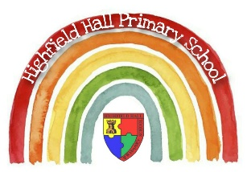

Spanish Core Knowledge Framework 2021-2022

The following framework has been developed taking into account the coverage completed in the previous academic year and the varying access of pupil during remote learning. Additional time has also been allocated for consolidation of previously taught content.

 | Autumn | Spring | Summer | Have also previously  covered (please revise)
3 | Greetings  How are you?  1a/b | Numbers (age and dates)  2a/b and 8a/b | Myself and the things I do | N/A
4 | Colours  3 | Animals (pets)  5b | Foods  9a/b | N/A
5 | School  4 | Parts of the body 13 a/b/c | Planets  12 | Family  5a
6 | Weather including some larger numbers)  10/11 | Sports  14 | Town  16 a/b/c | N/A

Please also be mindful of the following:
Children are entitled to quality teaching of MFL the same as all other subjects. A minimum of 30 minutes should be allocated on the timetable every week.
Additional short reinforcement would improve our provision through the week- taking the register, date in Spanish on display, singing songs
The first port of call for resources for many of us is the Lightbulb languages website. Please supplement these as necessary from other sources for revision. If you are not already aware, do not dismiss the Oak Academy sessions as they written by the same author.
There should be coverage of listening, speaking, reading and writing in the language.
You are not alone. Many of us teaching this do not have any specific qualifications in this language. We're all here to support each other.
Prior teaching in some year groups has varied between classes. Moving forward, please liaise with the person teaching Spanish in the parallel class to support consistency of experience. When I know who is teaching Spanish in each of the classes, specific guidance will be passed regarding their previous pathway.

