# H:\Logo.jpg

Year 5 – Spring 1: What is life like in the Alps?

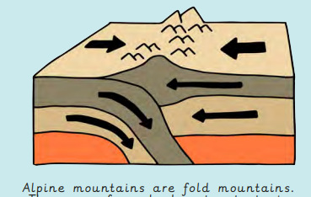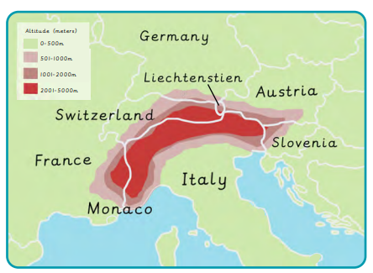

|  |
| --- |
| **Key Theme** |
| H:\2022-2023\New folder\These ones\Nature icon 1.png |

|  |
| --- |
| **CARE Value Focus** |
| Aspirational  Respectful |

|  |
| --- |
| **Sticky Knowledge & Skills** |
| * I know that Mont Blanc is the highest mountain in the Alps * I know that the Alps run through eight different countries and can name them. * I can name some human and physical features found in the Alps. * I know that mountain ranges also occur in most other continents and can name some. * I know that mountains often occur at plate boundaries. * I know that a mountain has to have a peak of at least 600m |

There are four types of mountains-

fold, fault-block, dome and volcanic.

|  |
| --- |
| **Where are the Alps?** |

|  |
| --- |
| **Key Texts** |
|  |

|  |
| --- |
| **Links to past and future learning** |
| In Y4 we learnt about volcanoes  In Y6 we will learn about the Oceans |

|  |  |
| --- | --- |
| **Key Vocabulary** | |
| altitude | the height of an object or point in relation to see or ground level |
| fold mountain | a mountain formed when two tectonic plates are pushed together and the ground is forced upwards |
| leisure | the use of free time for enjoyment |
| tourism | travel for pleasure during which people visit places of interest |
| tourist | a person who travels to a place for pleasure |
|  |  |

|  |  |  |  |  |  |  |  |
| --- | --- | --- | --- | --- | --- | --- | --- |
| Geography | | History | | Science | | RE | |
|  |  | When did the first Moon landing happen?  Who was the first person to walk on the moon?  Name 3 astronauts  Name 3 scientists who developed theories for the structure of the solar system. | 20th July 1969  Neil Armstrong  Various answers  Ptolemy  Nicolaus Copernicus  Galileo | Starting with the planet closest to the sun, what is the order of the planets in our solar system?  How long does it take for :  - The earth to rotate once on its axis?  - The earth to orbit the sun?  - The moon to orbit the earth?  Why do we experience day and night on earth?  Why do the planets orbit the sun? | Mercury, Venus, Earth, Mars, Jupiter, Saturn, Uranus, Neptune.  Approximately 24 hours.  Approximately 365 days.  Approximately 28 days.  Because the earth rotates on its axis every 24 hours.  The huge mass of the sun creates a strong force of gravity. | What was Jesus’ mission statement?  What is a parable?  Give an example of a parable | To preach good news to the poor  (give them a positive message)  To proclaim freedom for the prisoners  Recovery of sight for the blind,  To release the oppressed.  A parable is a simple story which has a special religious or moral meaning at the end.  The Unforgiving Servant  (Forgiveness)  The Good Samaritan (Love) |