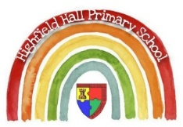
Year 5 – Spring 2: Conflict and Resolution
Key Theme

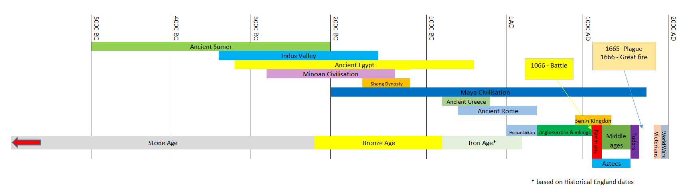
Key Texts
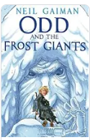
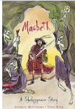

Core Value Focus
Curiosity, respects, critical thinking, resilience, compassion.

Links to past and future learning
In year 4 we learnt about the Viking raids and invasions on England.

In year 6 we will learn about the modern conflict which impacted Britain; WW2.

Sticky Knowledge & Skills
- I know that the Vikings arrived in England in the late 8th Century.
- I am able to name some Viking and Anglo-Saxon Kings.
- I know that England was divided between Viking and Saxon kingdoms during the 10th Century.
- I can name the three people involved in the battle for the English throne in 1066.
- I know who won the battle of Hastings.
- I know how England changed after the Norman conquest.
- I understand why the Domesday book was created.

Key Vocabulary
Chronology | Events organised in time order.
Century | 100 Years
Anglo-Saxons | Descendants of the Angles who battled the Vikings for control of England.
Normans | People of the Normandy region of France. They were led by Duke William.
Baron | Noble landowners who pledge their loyalty to the king.
Bayeux Tapestry | An embroidery which tells the story of the Norman conquest.
Conquest | Taking control of an area by force.
Feudal system | The Social structure of Medieval England
Cavalry | Soldiers who fight on horseback.
Reign | The period a monarch spends ruling.
Motte and Bailey | A type of fortification made from wood and earth.
Keep | The most protected part of a castle.

Geography |  | History |  | RE
Where is Normandy?  Where did the Vikings come from?  What sea did the Vikings cross to invade England?  What sea did the Normans cross to get to England? | Modern Day France  Norway / Denmark  North Sea  The English Channel | Who became King of England after Edward the Confessor died?  Where were the two battles fought in 1066?  Who did Harold Godwinson defeat at Stamford Bridge?  Name some rulers prior to 1066  Who became the king of England after the Battle of Hastings?  What is a Motte and Bailey castle | Harold Godwinson  Stamford Bridge  Hastings  Harald Hardrada  Ethelred the Unready, Cnut  Edmund Ironside,  Edward the Confessor,  Edward the Martyr  Sveyn Forkbeard  Edgar the Peaceful  William the Conqueror  A wooden enclosure connected to a raised mound with a wooden keep on top | What was Jesus’ mission statement?  What is a parable?  What was the parable of the two debtors about?  What does anoint mean?  What is a sinner | To preach good news to the poor  (give them a positive message)  To proclaim freedom for the prisoners  Recovery of sight for the blind,  To release the oppressed.  A parable is a simple story which has a special religious or moral meaning at the end.  Debtors who owed money – the one who owed more was more grateful  Jesus compared this to people who love greatly are forgiven greatly.  The act of pouring oil over somebody’s feet.  A person who sins

