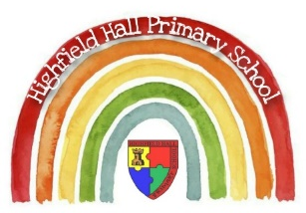
Year 2 – Spring 1
Key Theme

The Dragon Machine & The Great Fire of London
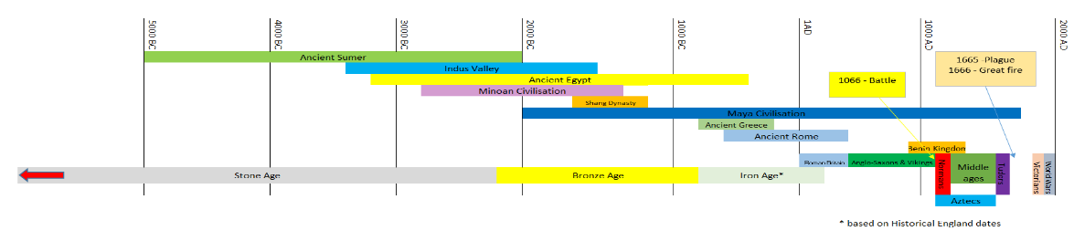
`
Links to past and future learning
In Y1 we learnt about
- hot and cold places and the equator
- the seasons
In Y2 we have learnt about
- our place in the world (me, my town, the nearest city, my country, my continent, the world)
In Y3 we will learn about
- the counties and cities of the UK (geographical regions)
- their human and physical features

Key People

Key Texts

Core Value Focus
Curiosity, critical thinking, resilience, compassion.

Key Vocabulary
Commemorative | To recall and show respect for something.
Historical artefacts | An object from the past that tells us about life at the time.
diary | A personal record of life’s events.
Eyewitness | A person who has seen something and can give a description of it.
fire break | When buildings are destroyed to make a gap so the fire can’t spread.
properties | The qualities or features that belong to something and make it recognisable.
flammable | When something burns easily
Aerial photograph | A photograph taken from the air.
Bird’s eye view | A general view from above.
Map | A drawing or of all or part of the earth’s surface.
Plan | A drawing or diagram.
Capital city | A capital city is where the government are based.
Country | An area of land with its own borders.

Sticky Knowledge & Skills
What is a human feature?
Can you give 3 examples?
What is a physical feature?
Can you give 3 examples?
Can you name the 7 continents?
Which of them do you live in?
Can you name any of the oceans?

Geography |  | History |  | Science |  | RE
What is a bird’s eye view? | A view of something taken from above. | When did the Great Fire of London happen? | The fire of London started in a bakery in Pudding Lane on 2nd September 1666. | How many materials can you name? | Examples may include | By what name to Muslims call their God? | Allah
What is an aerial photograph? | A photograph taken from above. | How do we know about the Great Fire of London? | Historians look at paintings, diaries, artefacts, documents and eyewitness accounts. | How can we change the shape of materials? | We can stretch them, bend them, twist them and fold them. | Muslims follow the example of a prophet. What is the name of that prophet? | The Prophet Muhammed
Name the 4 countries in the UK? | England, Northern Ireland, Scotland and Wales. | Why did the fire spread so quickly? | It hadn’t rained for months so the city was very dry. In 1666, lots of people had houses made from wood which burns easily. Houses were built too close together and there was no organised fire brigade. | What properties of a material make it suitable for what it is used for?  e.g. Why do we use glass for windows/ metal or plastic used for buckets now? | A range of answers explaining the material, the object and the propertied of the material. | What is the name of the building Muslims go to worship in? | Mosque
What are the 4 capital cities in the UK? | London, Belfast, Edinburgh, Cardiff. | How did they fight the fire? | They used leather buckets and squirts filled with water, axes, fire-hooks and gunpowder to make fire-breaks. | Why are houses now build from brick or stone rather than wood? | Brick and stone are hard and durable. They are less flammable than wood. | What is the name of the Muslim holy book? | Quran
 |  | What can we learn from this event?  How did life change afterwards? | They enforced that the buildings were build further apart and the buildings had to be made of brick or stone and not wood because it is flammable.  Today we have firefighters who have access to smarter equipment. |  |  | Name 3 facts about how Muslims pray. | Pray 5 times a day.  Pray facing Mecca.  Cover their heads when praying.  Pray on prayer mats.  Prayers involve standing and bowing.
 |  | How did the fire stop? | The fire burned for 4 days. As the wind died down and changed direction the fire became under control and was finally put out. |  |  | What is Wudu? | The act of washing their feet in the Mosque before prayers

