# \\10.4.91.2\TeacherShare\Curriculum\Agreed documents folder\Curriculum\Key themes\Explore.jpgH:\Logo.jpg

|  |
| --- |
| **Key Theme** |
|  |

Year 3 – Summer 2 – Ancient Egypt

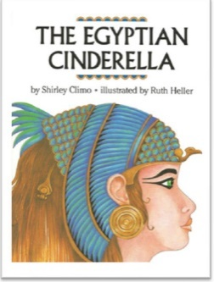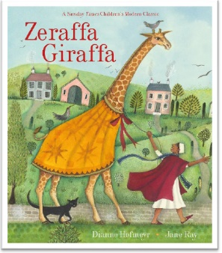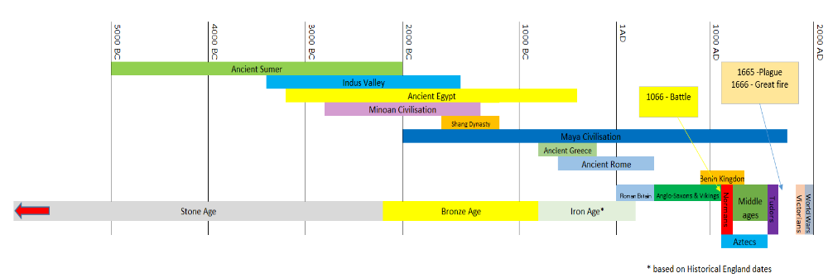

|  |
| --- |
| **Key Texts** |
|  |

|  |
| --- |
| **Links to past and future learning** |
| In Y2 we learnt about the lives of significant individuals in the past who have contributed to national and international achievements.  In Y4 we will learn about the Romans and how they fit into world history. |

|  |  |
| --- | --- |
| **Key Vocabulary** | |
| Artefact | An object made by a human being, typically one of cultural or historical interest. A primary source of history. |
| Mummification | The methods of embalming, or treating the dead body, that the ancient Egyptians used is called mummification. |
| Pharaoh | A ruler of Ancient Egypt. |
| Cartouche | An oval shape, used by the ancient Egyptians to write the names of their kings. |
| Sarcophagus | A stone coffin, typically adorned with a sculpture or inscription and associated with the ancient civilizations of Egypt, Rome, and Greece. |
| BC | An abbreviation **for Before Christ**, used to show that a year or century comes before the year in which Jesus Christ is thought to have been born. |
| Reflect | To bounce off |
| Transparent | Materials allowing light to pass through so that objects behind can be distinctly seen. |
| Translucent | Materials allowing light, but not detailed shapes, to pass through. |
| Opaque | Materials not able to be seen through; not transparent. |

|  |
| --- |
| **Sticky Knowledge & Skills** |
| * I know that the ancient Egyptians worshipped over 2,000 gods and goddesses. * I know about the mummification process and the reasons for it * I know about some Pharaohs and their impact on history * I know about and can talk about one of the wonders of the world – Pyramids of Giza * I know about the impact the Ancient Egyptian Civilisation has had on the modern world. * I know we need light to see things * I know that light travels in a straight line. * I know that dark is the absence of light. |

|  |
| --- |
| **Core Value Focus** |
| Critical thinking, emotional health, compassion. |

|  |  |  |  |  |  |  |  |
| --- | --- | --- | --- | --- | --- | --- | --- |
| Geography | | History | | Science | | RE | |
| In what continent is Egypt? | Africa | What is a wonder of the world? | The 7 Wonders of the World. Unique structure that creates wonder about its existence. | What is light? | A form of energy that travels in waves from a light source. | Where do you get help and advice from? | Mum, dad, teachers,  grandparents |
| What is the name of the River that runs through Egypt? | River Nile | What did the ancient Egyptians do to the Pharaoh’s who had passed? | Mummified them | What is a light source? | An object that makes its own light | Where might Christians get help and advice from? | God |
|  |  | Name the most famous Pharaoh of Ancient Egypt | Tutankhamun | Name some sources of light. | The sun, an electric light, a torch, a candle flame | What is it called when a Christian talks to God? | Praying |
|  |  | Name an example of a primary source of history | An artefact | What does reflection mean? | Light hits an object and bounces back into our eyes. | What is it called when a Muslim prepares for prayer? | Wudu |
|  |  | What does BC mean? | abbreviation **for Before Christ**, used to show that a year or century comes before the year in which Jesus Christ is thought to have been born ... | True or false?  Light travels in a straight line.  Humans can see in the dark.  Light travels in a wavy line. | True  False – we need light to see  False | Which direction to Muslims pray to? | They pray towards Mecca. |
|  |  |  |  | How is a shadow formed? | An object blocks the light creating a dark area. |  |  |
|  |  |  |  | How does a shadow get smaller? | You move the object further away from the light source. |  |  |
|  |  |  |  | Match the meanings and words.  Transparent  Opaque  Translucent | Does not let any light through – cannot see the object.  Lets some light through but it is scattered so you can’t see the object properly.  Light travels easily through them so you can see the object easily. |  |  |
|  |  |  |  | How is a rainbow made? | He light hits a raindrop and splits into the 7 colours of the spectrum. |  |  |