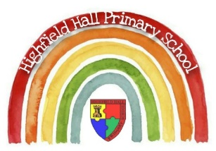
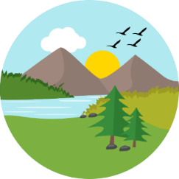
Key Theme

Year 2
How can we look after our environment and community?
Making Links and Connections
Links to past and future learning
In Y1 we learnt about…
- The parts of a plant
- Types of plants

In Y3 we will learn about…
- Plant dissection
- Plant growth
- Pollination

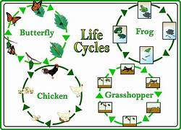
Key Vocabulary
persuade | Convince someone to do something by giving reasons and arguments.
endangered | A word that is used to describe plants and animals that are not doing very well and are at risk of extinction (dying out).
environment | The surroundings a living thing lives in or the conditions.
bulb | The name given to the underground bud or stem of a seed plant
seed | The small part of a flowering plant that grows into a new plant.
Life cycle | A life cycle is a series of changes that happens to all living things.
Physical feature | Physical features like seas, mountains and rivers are natural. They would be here even if there were no people around.
Human feature | Human features are things like houses, roads and bridges. They have been built by people.
Coastline | A strip of land that meets the sea or ocean. This land could be made of things such as rock, sand, mud or gravel
Key Texts
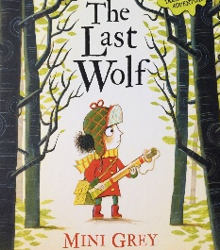

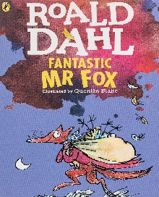

Core Value Focus
Critical thinking, emotional health, compassion.

Sticky Knowledge & Skills
- I can talk about the differences between a habitat and microhabitat.
- I know the difference between something that is alive, was never alive and is dead.
- I can name sources of food.
- I can recall some common habitats and microhabitats.
- I can work with others to build a bridge and make changes as I work
to it to make it stiffer, stronger or more stable.

Geography |  | Science |  | RE
What is a sea  Name the four bodies of water surrounding the UK  Name some key physical features of the UK  A sea is a body of water that is smaller than a what.  Name some key human features of the UK. | is a body of water that is smaller than an ocean.  English channel  North Sea  Irish Sea  Atlantic Ocean  Hills  Mountains  Valleys etc  ocean  Houses  Roads  Shops  Bridges etc | What is difference between a bulb and a seed?  What do plants need to grow?  What are offspring?  Can you name some? | A bulb is part of a plant which stores food and is found underground  A seed is part of a plant that grows into a new plant.  Sunlight, water, warmth  The young of an adult  Various answers | What is a holy book?  What do the stories told by Jesus in the Bible teach Christians about how to treat people?  What does the story of Muhammed and the Black Stone teach Muslims?  Who was the Good Samaritan?  What does the bible teach us in this story? | A book that has stories about God which are special to many people.  Forgive each other.  Be kind to each other.  Love each other.  Treat people the way you like to be treated.  Try not to argue.  Be fair.  Teamwork is good  He helped a man who had been attacked.  To love each other and treat people with respect.

