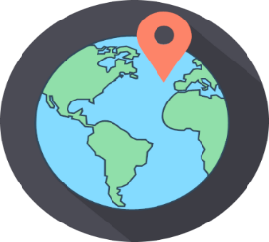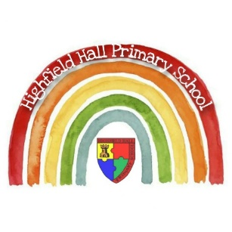

|  |
| --- |
| **Key Theme** |
|  |

Year 2 – Autumn 1: Troll Swap!

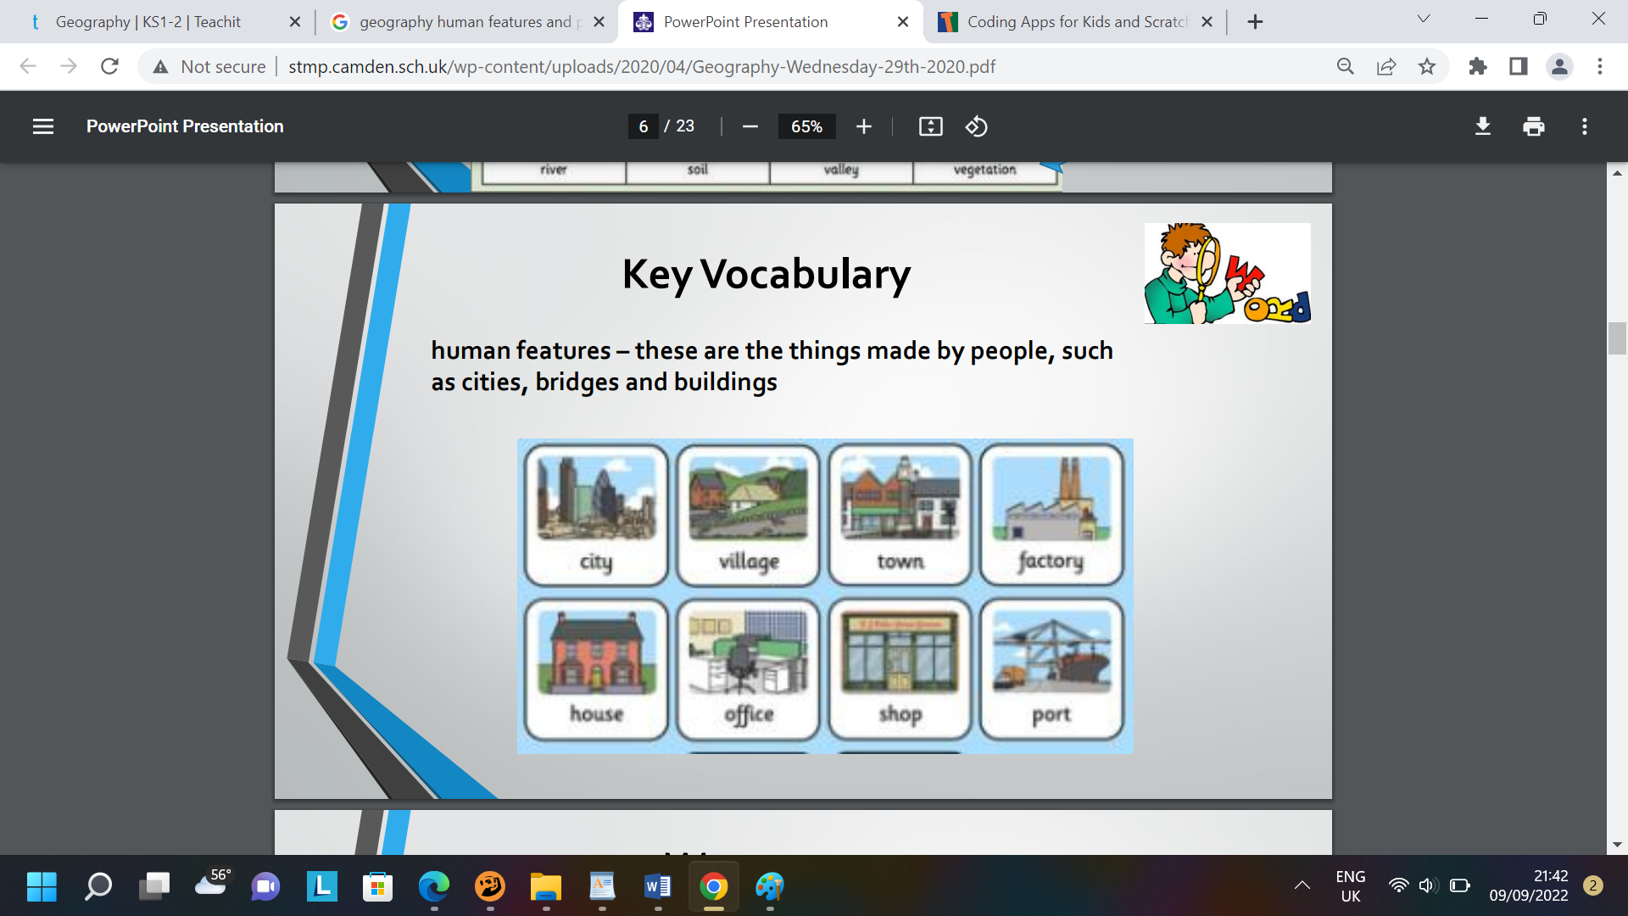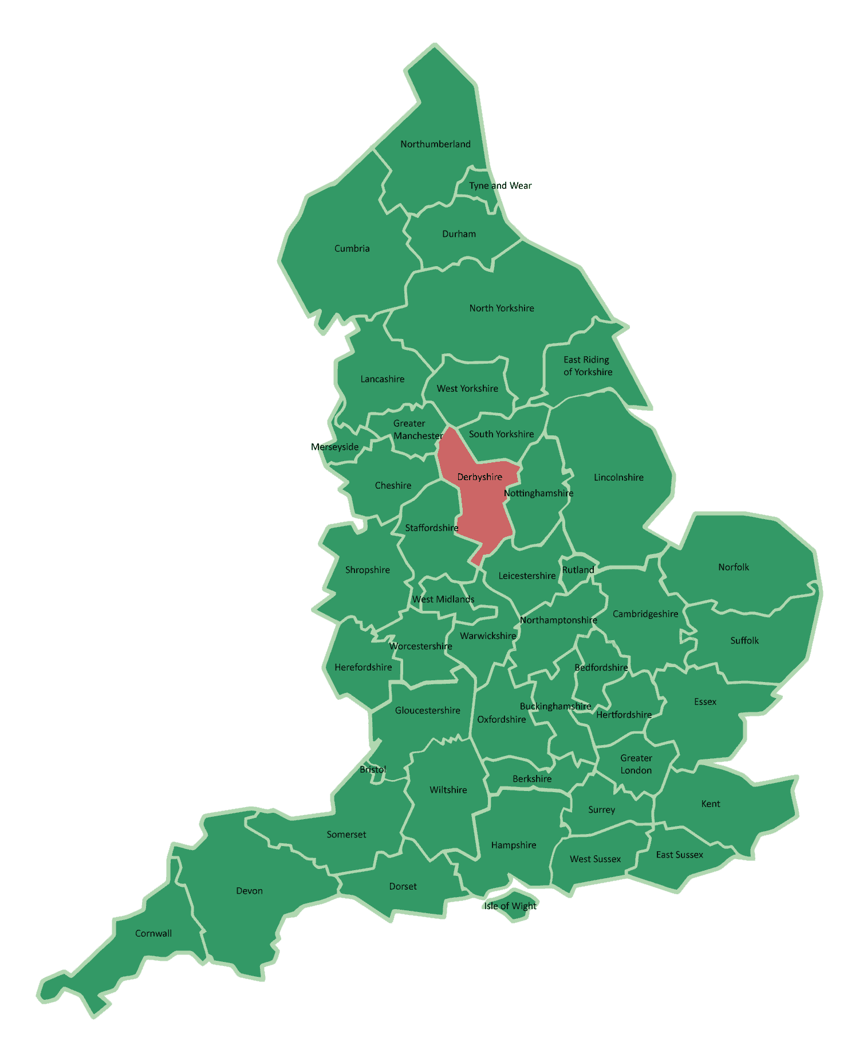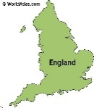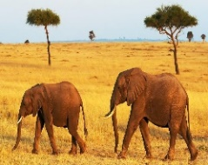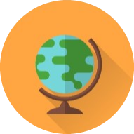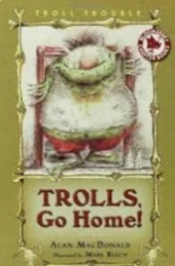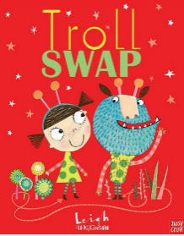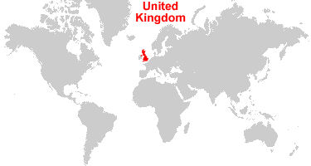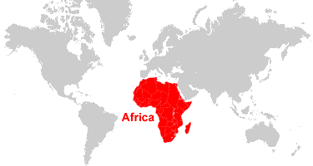

|  |
| --- |
| **Key Texts** |
|  |

|  |
| --- |
| **Sticky Knowledge & Skills** |
| * The village school is in is **Newbold**. * Our school is in a town called **Chesterfield**. * The closest city to our school is **Sheffield**. A city is a large town with a cathedral. * The county our school is in is **Derbyshire.** * The country our school is in is **England.** * England lies above the equator; it is cold in winder and warm in summer. * Kenya lies on the equator. It is hot, sunny and dry for most of the year. * I know London is the capital of England and Nairobi is the capital of Kenya. |

|  |
| --- |
| **Links to past and future learning** |
| In Year 1 we learn the 4 countries in the UK and the capital cities. We learn to describe some human and physical geography within England.  In Year 3 we develop our understanding of the world, looking at land use patterns and how physical geography changes over time. We use atlases and maps using compasses and 4- and 6-figure grid references. |

|  |  |
| --- | --- |
| **Key Vocabulary** | |
| Equator | An equator is an imaginary line around the middle of a planet. It is halfway between the North Pole and the South Pole. |
| Human features | Human features are features such as houses, roads and bridges and other features that have been built by people or humans. |
| Physical features | Physical features are features that were created by nature, not humans. They would be here even if there were no people around. |
| Temperate | Temperate places get cooler, wet winters and warm, wet summers. |
| Savannah | A rolling grassland scattered with shrubs and isolated trees |
| Ice sheet | A layer of ice covering an extensive area of land for a long period of time |

|  |
| --- |
| **Core Value Focus** |
| Critical thinking, resilience, emotionally healthy, compassion |

|  |  |  |  |  |  |
| --- | --- | --- | --- | --- | --- |
| Geography | | Science | | RE | |
| Name and locate the seven continents on a world map.  What are the 5 oceans?  Locate the North and the South Poles on a world map.  Locate the Equator on a world map.  Describe some similarities and differences between the UK and Kenya.  Recognise the features of hot and cold places.  Locate some countries with hot or cold climates on a world map. | Europe, Asia, Oceania, Africa, North America, South America, Antarctica  Atlantic, Pacific, Indian, Southern and Arctic  Show on map/globe  Show on map/globe  Weather, clothing, physical features  Sand, palm trees, snow, ice  Australia, Greece, Sweden, Alaska | What does a carnivore eat?  What does a herbivore eat?  What does an omnivore eat?  What do mammals have on their body?  What features do all birds have?  What features do all fish have?  Where do amphibians live?  What do animals need to survive?  Name the different groups of animals | Meat  Plants  Meat and plants  Fur or hair  Feathers, wings, beaks  Gills, scales, fins  On land and water  Air, food, water, shelter  Amphibians, mammals, birds, fish, reptiles | |  | | --- | | What does ‘gospel’ mean? | | Which of these is the odd one out in what Jesus taught? Circle your answer. Forgiveness Anger Peace Love | | Jesus looked inside the ________________ of the people he chose. What is the missing word? | | Retell Matthew's story. (draw/act/speak/write) | | What instruction does Jesus give to Christians in the bible? | | Write down a way that Christians bring ‘good news’ to people? | | |  | | --- | | Good news | | Anger | | hearts | | Jesus chose a man named Matthew who was a tax collector (and were hated) to be his follower. Jesus showed forgiveness to Matthew by asking him to become one of his followers. | | To forgive - ‘forgive and you will be forgiven’ | | helping in or donating to a charity shop, serving at or donating to a foodbank, helping homeless people etc. | |