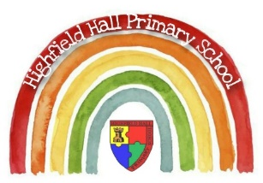
Year 1 – Spring 2: The Curious Case of the Missing Mammoth
Core Value Focus
Creativity, critical thinking, curiosity, resilience, emotional heath.

Key Theme

History Sticky Knowledge
We understand that when we talk about the past we are talking about events which have already happened.
We can use a timeline to show the passage of time.
We can compare historical objects with modern ones and identify whether an object is old or new.

Key Vocabulary
peep | look quickly or through a narrow gap
gasp | catch your breath
thunderous | loud or angry
mammoth | large, hairy elephant - extinct
exhibits | displayed publicly like in a museum
extinct | a group of animals having no living members
carnivore | eats other animals
wild | living in their natural environment
endangered | at serious risk of extinction

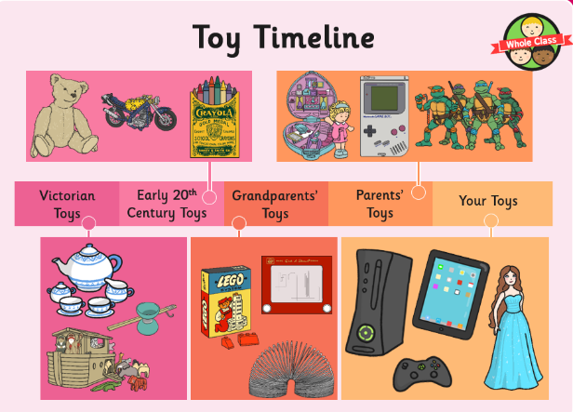
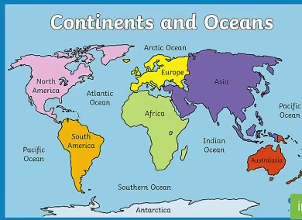

Key Texts
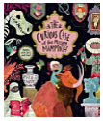
Science Sticky Knowledge/key questions
We can look at the everyday objects and identify the properties of the materials they are made out of.
How do you know what material an object is? Which is the hardest material? Which material would you use if you were building a window? What material is a table made from?

Links to past and future learning
Last year we painted self-portraits, thinking about colour. We will build on this to incorporate colour mixing and brush skills.

In reception have had a lot of practice at making structures through junk modeling. In year 1 we are now linking our skills of junk modeling with our science knowledge. This term we will be making toys with levers and joining using different techniques.

History |  | Science |  | RE
Name a toy that your grandparent might have had.  How can we tell toys are old?  What were our grandparents toys like? | Xbox, Dolly, Lego  (wear and tear, material)  (Wooden, plastic,) | Which material is Lego made from?  Which material is a scooter made from?  Which properties would you use to describe a teddy bear?  Name as many properties as you can to describe a toy car? | Wood, plastic, metal  Wood, plastic, metal  Soft, hard, smooth  (smooth, shiny, cold) | Name a symbol of belonging to Christianity.  Name a symbol of belonging for Jews that is used at the Shabbat.  Give an account of what happens at a baby’s traditional baptism.  How do Christians show they belong to each other at a traditional wedding? | Church, cross, fish, bible, candle.  Kiddush cup, Challah bread.  Water is poured over a baby’s head 3 times.  Give rings and make promises to God.

