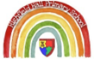  Knowledge Organiser  Nursery  Autumn 2 - 2022 |  | Our Key Text:  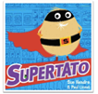
Key Nursery Rhymes: | I’m a little teapot  Hickory dickory dock  Tommy Thumb | Cultural or religious festivals: | Halloween  Bonfire night  Christmas around the world  Remembrance Day
Specific vocabulary: |  | Sticky knowledge & skills:
Tier 1 | Tier 2 | Our teachers are helping us to...  Know how to put our coats on by ourselves. 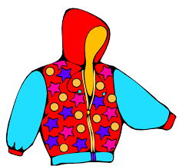  Name at least three vegetables.  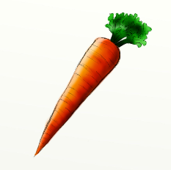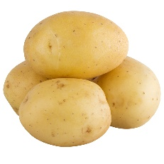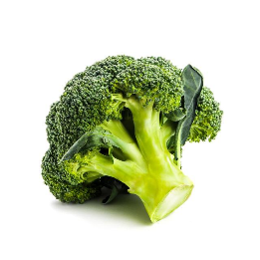
vegetables | crept
supermarket | yelled
frozen | marched
potato | rescue
mashed | escapee
How you can help us at home:

Talk to us about people who help us. Perhaps you could spot an ambulance, a fire engine or a police car.

Let us put our coats on by ourselves. We are learning to do zips too.

Take us to the supermarket. Talk about the vegetables you see. Maybe you grow your own?

Talk about, and involve us in, family celebrations.

